12 Days of Manifesting
Creating Your Divine Ritual & Totem
Day #3

Disclaimer: This transcript has been edited; however, there may be English or grammatical errors since it is spoken English, as opposed to written English. Please ignore the errors (or let us know where they are so we can correct them). Enjoy the call!

This is Rev. Anne Presuel of Divinely Intuitive Business. We are here for day 3 of our 12 Days of Manifesting program. Today, we’re talking about rituals and totems that will support you in creating and manifesting what it is you want.

I love the topic because I love creating these things, or looking for them or looking for ways to – easy simple ways that will support me, fun ways that will support in creating and manifesting what I want.

I going to just say what a ritual is. You know what a ritual is like you go to a wedding. That’s a ritual. You go to a funeral. That’s a ritual. You go to a graduation. That’s a ritual. If you’re the one graduating, you’re going through the ritual.

It’s a celebration. It’s an acknowledgment and it’s an announcement, if you will, to the world of who you are and where you are and what you’re doing. Sometimes, it can just be an announcement to yourself. The ritual that we do that we create for ourselves You don’t have to create it for everything.

When you hit a milestone in your business or you hit a milestone in your life, how do you celebrate? I highly recommend that creating some kind of a ritual. A ritual that will allow you to anchor in that energy of that milestone.

And here, we’re talking about manifesting so, how do you create a ritual for something you haven’t created yet? Or do you do that for something you haven’t created yet? You could. I use totems to help me create. Is it true? People swear by it. Totems help. They help hold the energy of what you’re looking for.

Here’s the thing. When we have a vision of manifesting something, we then our work is to get into alignment with what we’re looking to manifest. Getting in alignment means being able to hold the vision, being able to have it be a, “Of course, I can do that,” “Yes, I got it. I can do this.” It’s like a “what is” instead of “what I want it to be.”
When you are manifesting, you’re working on changing on your own energy, your own mindset, your own self to be able to hold the vision of what you want.

Jewelry is a wonderful totem but you don’t have to go into something huge or expensive. It can be something smaller.

You can create an altar. An altar that is reflection of what you want to create, has some pieces of pictures. Something that holds the energy of what you want to create.

What is it?

I create list. I love list. I love journaling to whatever it is I’m wanting to create. I love to journal to it, to talk to it, talk to the energy of that being or that thing because, you know, everything has energy. I’m not speaking crazy to anybody. You get everything has energy. Your programs have energy. Your business has energy. Your vision has energy.

If you start to pay attention, you can feel things talking to you. You can feel your future calling you. You can feel that vision calling you. You feel it. It feels like an ache. It feels like a hunger. It feels like a desire. It feels like “this is coming” and it feels like a certainty. Even if it’s not manifested in front of you right now, you can still, you pay attention, you can feel it. And you can support it by giving either some kind of ritual or an ongoing ritual, say, journaling is a great ritual.

But what can you create yourself? What kind of ritual can you create? What kind of totems? What do you like to do? It doesn’t have to be big.

If you use the totem, it will help you retrain your brain from “God, this is so hard” to “That was easy.” It’s the totem that helps you hold the energy of the vision you have. That’s the power of this. And, of course, you can do it without but like, “Why?” Totems are fun. That’s the fun part of co-creation. They help you remember.

We’re not even talking about energy exercises. All we’re talking about here are rituals and totems today that will help you remember, help you hold the vision, help you hold the energy of that which you desire to create.

You ask it to support it, you can do a whole ritual yourself by doing them intentionally like blessing them, cleansing them as they are something that maybe was used like crystals. You can find crystals and you want to help them help you. Charging them in the light or in the moonlight, depending on what kind of crystal it is.

Using essential oils for yourself before you even, for those of you who love essential oils, as you dedicate whatever it is you’re doing or a vision book or a vision board if you like doing vision boards.

Blessing what it is that you’re doing. Blessing the item and thanking it for holding that energy.

Connecting with things. Connecting with the energy of things.

Energy is all from the Divine but everything has energy, asking it to support you, asking it to help you create this vision and dedicating them. It doesn’t have to be a big, heavy thing. It can be fun and light and easy.

Alright, Divine ones. Thank you for being here. Thank you for being here live. Thank you for sharing. Thank you be making a difference in other people’s lives by sharing yourself, by contributing. It makes a difference.

Have a beautiful, beautiful day.

Go get your Divine ON,

Bye, everybody.

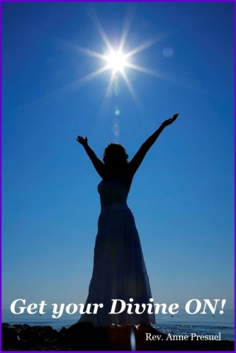
xoxoxo,
Anne

Rev. Anne Presuel
Your 6th Sense Guide to a 6-Figure Business
DivinelyIntuitiveBusiness.com

