“I'm afraid of being too visible!” ​
Class #4 – Tapping Transcript

Disclaimer: This transcript has been edited; however, there may be English or grammatical errors since it is spoken English, as opposed to written English. Please ignore the errors (or let us know where they are so we can correct them). Enjoy the call!

Let’s declare our intention….

We call in our guides, call in our angels, let’s call in the Divine.

We say, “Thank you.”

Thank you, thank you for the opportunity to grow and expand our awareness of who we are, of how magnificent we are, to see ourselves through the eyes of the Divine because we are the eyes of the Divine,

To choose to be in alignment with that vision.

Thank you for the opportunity.

We are grateful and it is indeed so.

Let’s start tapping…

Start tapping at the top of your head:

Even though I have a fear of being seen and being judged by, hell, everybody,

I have a fear of being seen for who I really am,

My weird sense of humor,

My too loudness,

My too bigness,

My too smallness,

My too softness,

My too sensitiveness,

My too… whatever,

Whatever it is that I’ve got going on in my head that says I am too much or too little of something,

I’m aware of it.

I’m present to it.

I’m judging it myself.

I’m judging the shit out of it right now.

I’m judging that I have it.

Wishing that I didn’t.

Wanting it to go away.

And even though I have this,

I have this crazy world going on in my head,

I deeply and completely love and accept myself.

I am willing to see myself differently.

I am willing to see myself through the eyes of love,

Through the eyes of joy,

Through the eyes of acceptance,

Through the eyes of kindness and compassion.

I’m willing to let go of those lifetimes of horror where I was judged,

I was shamed,

I was tortured,

I was killed for being someone that was not acceptable in that society, in that culture.

I am willing to let go, to cut my ties, to cut the cords of those lifetimes, those memories so they do not carry forward into this lifetime, into this work that I’m doing now.

Because this work that I’m doing now is powerful.

It is essential.

It is the work of love.

And because it is the work of love, I call in that force within me.

I call it forth and ask it to be here to show me how to be it, how to embody it, how to share it with the world, this force of love,

Letting go of the judgments that I have within my heart about the way I look,

The way I sound,

The way I speak,

The way I walk,

The way I talk,

The way I share,

The way I stumble.

I’m letting it go for I do not need to carry that forward.

I do not need to carry that forward with me.

It does not serve me any longer.

It does not serve me any longer this judgment that I have,

This abandonment of myself that I do.

Not because I want to,

But because I learned it early on for survival.

I had to survive.

I had to make it.

Survive in my own family who didn’t know any better,

Who couldn’t do better for me.

Because, they, too, have been taught to abandon themselves.

But without that training, I would not be who I am today.

I would not have the sensitivity and the awareness that I have today without their gift.

Painful though it was.

I have awarenesses of who I am.

And I am unwilling to have their standards, their judgments, their decisions of who I am and how I should be, rule my life anymore.

I let that go.

I choose to bless it and to release it.

I choose to say. “Thank you.”

“Now, be gone, would you? Get out of here!”

“I don’t need you anymore!”

“Go away!”

“Fuck off!”

“Thanks!”

“Bye! Don’t let the door hit you on the ass on the way out.”

“See you! Wouldn’t want to be you!”

“After a while, crocodile!”

“Be gone, would you?”

“Seriously, out of here!”

I do not need to carry that forward into my future.

And so, I choose,

I choose to let it go.

I choose to say, “Thank you. I don’t need it anymore.”

Those who judged me are judging because of their own limited view point,

Their own lack of understanding,

Their own training.

They don’t know any better either.

So why would I let that stop me?

Why would I choose to let that stop me?

My fear of that stop me from showing up into the world who I am,

This magnificent, glorious being,

Just the way I am.

Owning it, celebrating it, being it.

In all my magnificence, I am unwilling to do that to myself ever again.

I am unwilling.

I call in the true me,

The magnificent, glorious, powerful, incredible me,

And share that person with the world.

Share that person with the world.

Because that is who the world is looking for,

That is who the world wants,

That is who the world needs.

And that’s who I am.

Strong, beautiful, profound, brilliant, trained, compassionate, funny, glorious,

That is who I am.

And so it is.

Go get your Divine On!

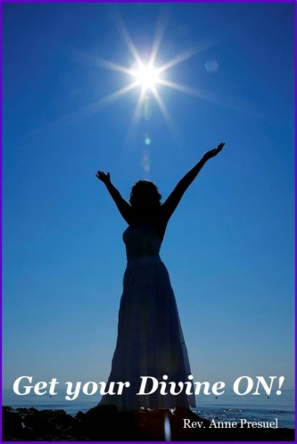
Divine hugs,
Anne

Rev. Anne Presuel
Your 6th Sense Guide to a 6-Figure Business
DivinelyIntuitiveBusiness.com

