"I just want clients to show up!”
Class #8 – Tapping Transcript

Disclaimer: This transcript has been edited; however, there may be English or grammatical errors since it is spoken English, as opposed to written English. Please ignore the errors (or let us know where they are so we can correct them). Enjoy the call!

Let’s declare our intention….

Let’s call in our guides, call in our angels.

Take in a nice deep breath, call in the Divine.

We say, “Thank you” with full hearts, grateful minds, for the awareness of who we truly are, for the clarity and the willingness to show up as that.

Thank you for the clearing of anything that is in the way of our showing up in this way.

We say, “Thank you.”

And so it is.

Let’s start tapping…

Start tapping at the top of your head.

Even though I want clients to show up,

“Just show up, please.”

I don’t really want to have to do a lot of work to go get them.

Sometimes, I don’t even know what I have to do in order to go get them.

But I do know I want them here.

I want them in my life.

I want to see them.

I want to support them.

I want to help them.

I want to work with them.

And, I want to be paid for the work I do.

Even though I just want my own magic wand,

I want my magic wand and I want people to recognize the ways in which I am magic.

Heck, I want me to recognize the way in which I am magic.

And there are times when I do.

There are times when I am so clear that I am an incredible, magical, manifesting being.

And then, there are times when I get confused, when I forget, when I don’t know.

There are times when I get frustrated with myself,

When I get frustrated with those around me,

When I get frustrated.

And I think, “I don’t know what’s going on.”

And then, I remember that all is in Divine order.

Then, I remember that everything is always working out for me.

And I remind myself that I am expecting things to work out for me.

I remind myself that it’s okay to have things work out for me.

It’s okay to have a life that isn’t filled with drama.

It’s okay to have a life where life is smooth and ease-filled and joy-filled.

It’s okay to have a life where love reigns,

Where trust in myself and in the process and in the Divine is the way I roll.

It’s okay to have that kind of a life.

It’s okay to be happy.

It’s okay to be happy.

It’s okay to be the essence of flow.

And when I realize that I am out of alignment,

That I’m running my stories,

That I’m back in my ego,

Back in fear,

Back in “must to do this right,”

“must to do it a certain way,”

“should happen a certain way.”

When I realize I am doing that, I turn into gratitude.

I turn to gratitude and I turn into gratitude.

I become gratitude.

I choose gratitude.

I choose recognizing everything is working out for me.

And it may look different from what I think it should.

And I remember all the times that things worked out for me differently than what I thought they should.

And how much better they turned out because of that.

Because the Divine has my back.

The Divine has my back.

And I can trust that.

I don’t have to control everything.

I don’t have to make it happen.

I can be the space of allowing, of trusting, of taking those actions that might seem frightening.

But knowing full well that my guidance, my intuition is guiding me to that right next step.

And I can trust it.

And if I don’t, I’ll be guided again.

I’ll have another opportunity.

I can trust.

I can trust that everything is always working out for me in a highest and best good.

For that, I am profoundly grateful.

I am profoundly grateful.

I trust myself.

I trust my guidance.

I trust my guides.

I trust my angels.

I trust the Divine.

I am trust-worthy.

I am profoundly intuitive.

I trust my intuition.

I trust that I am cared for, and guided, and protected.

I trust my path.

I trust myself.

I trust the Divine.

I trust.

I trust.

And I know that my clients are looking for me.

I know that I have what they need.

I know that they want what I’m offering.

I know that they seek what I am sharing with the world.

And I allow. I allow them to find me.

I clear my energetic blocks.

The things that say, “It can’t be easy,” “It must be hard because it’s always been hard.”

I clear anything that is in the way of me being the space of magic.

Of me being magic,

Of me owning my magic,

Of me claiming my magic,

Of me sharing my magic,

Of me celebrating my magic.

I clear that which says, “No, you can’t,”

“No, you shouldn’t,”

“Don’t be too visible,”

“Don’t let them see,”

“Don’t do that,”

“Do something safe.”

I choose differently.

I choose differently.

I choose to be magic.

I choose to be magic.

I choose to call in every breath of magic that I have,

Every breath of magic that I am.

I call it in so that I may be that in full expression for myself, for my clients, for my business, for my life, for my finances, for my relationships.

I call in me as magical being.

And I claim it.

I am magic.

I am magic.

I am magic.

This is my truth.

This is my truth.

This is my truth.

And so it is.

(Nice deep breath, everyone. Nice deep breath.)

Magical beings.

This is who we are.

As we share ourselves with the world,

As we take ourselves out into the world claiming our magic,

So that we know we are magic.

Everything flows from there.

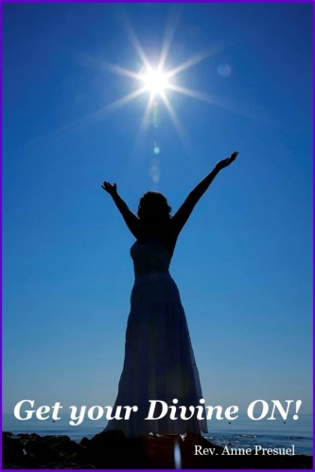
Go get your Divine On!

Divine hugs,
Anne

Rev. Anne Presuel
Your 6th Sense Guide to a 6-Figure Business
DivinelyIntuitiveBusiness.com

