Resources
Handout

Here are some yummy resources for you to get more information and education on not only tapping, but also other powerful energy techniques that I share in this program.

Jin Shin Jyutsu

Jin Shin Jyutsu is an energy technique that I swear by. It is simple to use. Just take the fingers on one hand and wrap them around the specific finger on the other hand and breathe. Feel the energy shift and release. (For me, it feels like the intensity just drains out.)

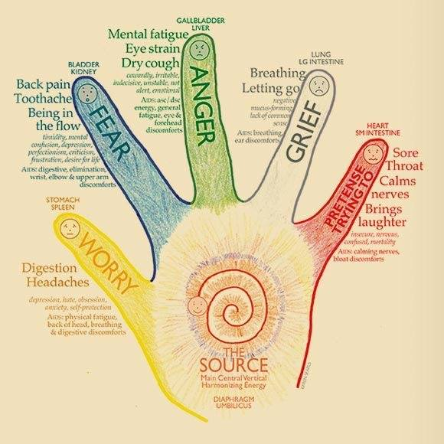

Donna Eden’s energy techniques

You can find many of Donna’s techniques on YouTube.
Here is her daily 5-minute energy technique:
https://www.youtube.com/watch?v=gffKhttrRw4

The Mudras

You can learn all about the mudras in this wonderful article:
https://curiousmindmagazine.com/hand-position-something-incredible/

