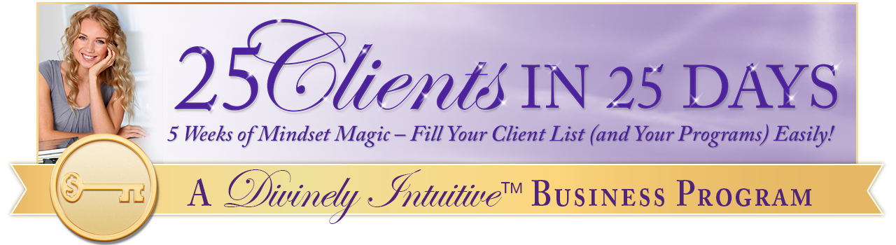
Mudra Hand Positions
Handout

URL: https://curiousmindmagazine.com/hand-position-something-incredible/

Holding your hand in this position does something incredible for your body.

If we consider the world we live in and the pace of life we go through each day is no wonder we constantly suffer from aches and pains in both our body and mind.

Aside the traditional medicine, pills, painkillers or similar medications, people very often rely on yoga, meditation or acupuncture. These are all fine and useful methods put there’s another more simple method that many Westerners haven’t even heard of.

We’re talking about Mudra Hand Gestures, a method which originates from India. The method stimulates various parts of the body and mind while relieving different kinds of pain and ache.

The method consists of eight basic hand gestures. Perhaps you’re a skeptic now, but once you see how powerful the gestures are you’ll use them regularly.

Try them and let us know what you think…

- Gyan Mudra

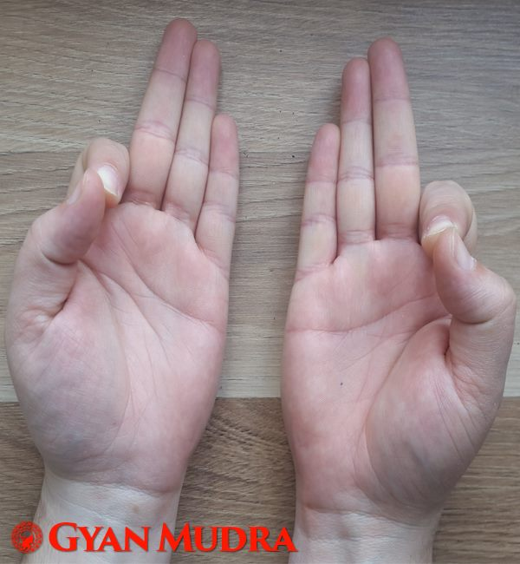

If you’re feeling down lately, try this hand gesture. The gesture is thought to increase the air element and raise your enthusiasm, increase creative thinking and remove laziness.

- Vaayu Mudra

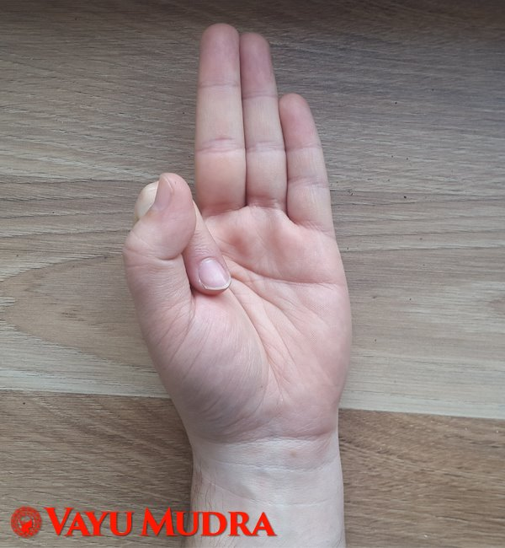

Anxiety is the 21st century’s worst illness I’d say, so we should try and get rid of it in every possible way. Do this hand gesture which is believed to decrease the air element and reduce anxiety.

- Aakash Mudra

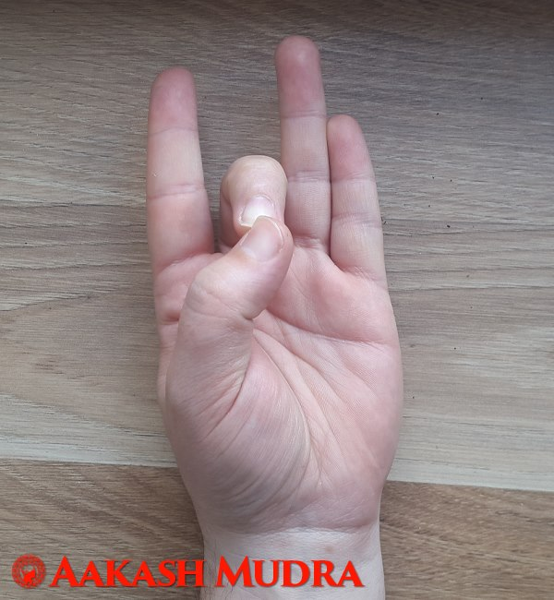

This hand gesture is intended to increase the space element. Do this and you’ll get rid of the fear, sadness, rage and congestive problems.

- Shunya Mudra

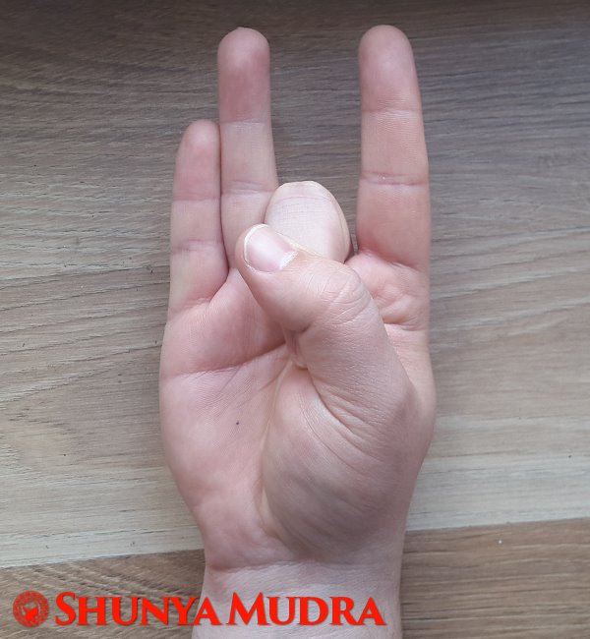

This hand gesture reduces the space element and is effective in relieving ear pain.

- Prithvi Mudra

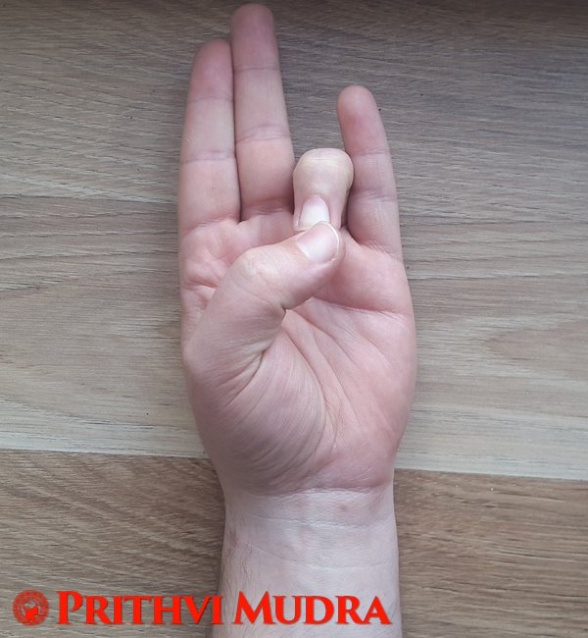

If you’re feeling tired and you’ve got sore muscles, this hand gesture is the solution for your problems. It is believed to increase the earth element and reduce the fire element.

- Surya Mudra

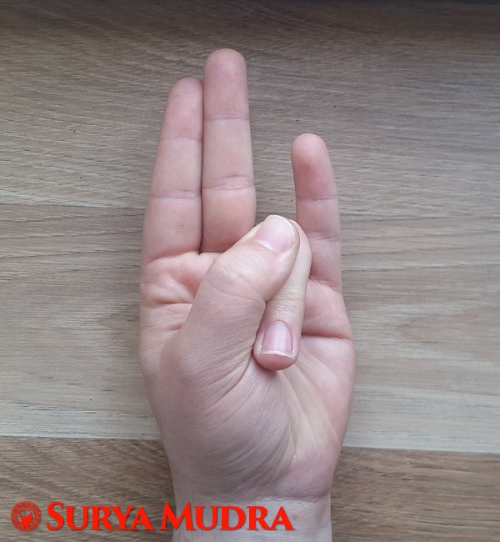

This hand gesture does the opposite from the previous one. It decreases the earth element but increases the fire element. It’s perfect for those with thyroid gland malfunction.

- Varun Mudra

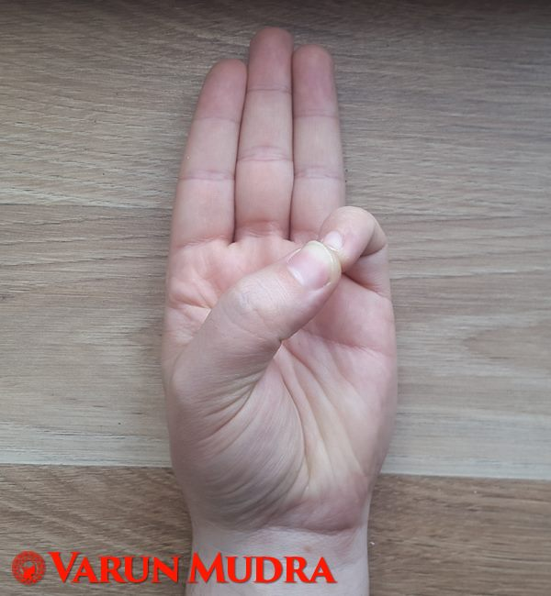

Do this hand gesture and get rid of cramps, ache in the joints and arthritis. The gesture is intended to increase the water element.

- Jal Shaamak Mudra

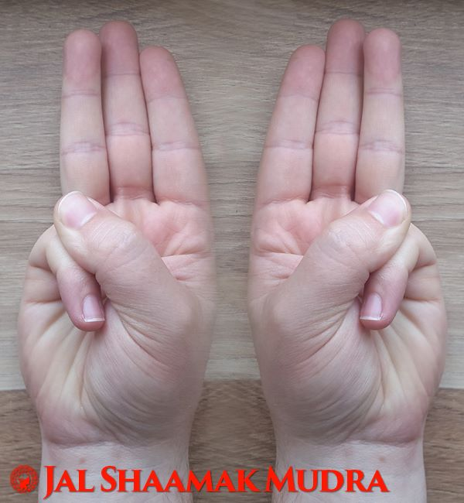

This hand gesture is considered to reduce the water element. It is helpful to those who suffer from watery eyes, runny nose or have problems with excessive sweating.

Isn’t this great and super easy by the way? You can do these hand gestures anywhere you want. Do them at your home, in the office or in the park. Give it a shot! After all there’s nothing to lose but plenty to gain.

Share these useful tips with your friends and family and go through your days happier, more confident and pain free.

