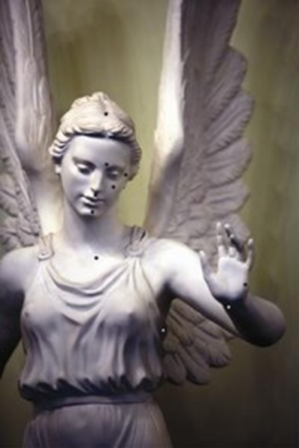
Tapping Points
1) Sore Spot
On chest, below collarbone 3”
& to the left or right 3”
2) Top of Head
3) Eyebrow
4) Side of Eye
5) Under Eye
6) Under Nose
7) Chin
8) Collarbone
9) Under Arm
10) Wrist
11) The Karate Chop
Side of Hand

For the tapping points, as well as an audio explaining where each of these points is, visit this link:
http://divinelyintuitivebusiness.com/tapping-points

Divine hugs,

Anne

Rev. Anne Presuel
Your 6th Sense Guide to a 6-Figure Business
DivinelyIntuitiveBusiness.com

