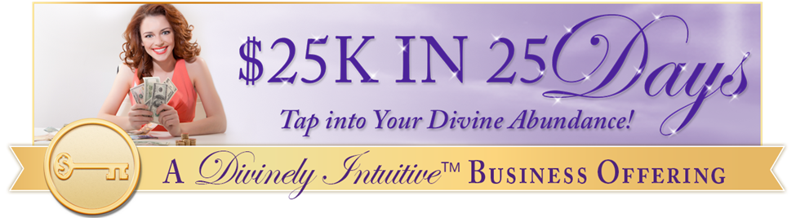
" I'd have to sell my soul
to get the money I want”
Day #16 - Tapping Transcript

Disclaimer: This transcript has been edited; however, there may be English or grammatical errors since it is spoken English, as opposed to written English. Please ignore the errors (or let us know where they are so we can correct them). Enjoy!

Let’s declare our intention…

Let’s call in our guides and call in our angels and we say “Thank you.”

Thank you, thank you for this opportunity to heal beliefs that keep us from the abundance, the wealth, the riches of life that are ours by our Divine birthright.

Thank you for helping us shift out of the mindset that “We can’t have what we want. We’re not good enough. We don’t deserve.”

That in order to have what we want, we have to pay dearly.

We are ready to let this go.

We welcome the “ahas,” the downloads, the awarenesses, the transformation, the healing.

And we say “Thank you.”

We know that this is so.

And so, it is.

Let’s start tapping…

Even though I have a real fear of having all that I want,

Of having more than what I want,

More than what I asked for,

More grace, more joy, more abundance, more money.

I have a fear of having that.

Because it’s been taught it’s not okay.

I’ve been taught it’s not okay.

It’s not okay to have an abundance of money.

An abundance.

Hundreds of thousands of dollars, tens of thousands of dollars, millions of dollars in my bank account.

I’ve been taught that that is not okay.

That is the devil’s playground.

And we’re in there playing in it,

When we want something,

When we have a dream,

When we desire,

We desire more than what we have.

Even though I have that,

Even though somewhere inside of me, this says “This is truth,”

Even though all of that,

I deeply and completely love and accept myself.

I deeply and completely love and accept myself.

I have this vision.

I have this desire.

This desire of having more,

Of having more in my life,

Of having more.

More freedom,

More wealth,

More abundance,

More riches.

I have a desire for more.

And I feel guilty.

I feel guilty that I want more.

I feel guilty that I’m asking for more.

I’ve been told that in order to have more,

I’m going to have to sell my soul.

I’ve been told that having more equals selling my soul.

I’ve been told that by people I trusted,

People I believed they knew what they were talking about.

Could it be they were wrong?

Could it be they didn’t know?

Could it be they were taught something incorrect as well?

Could it be?

Could it be they have lifetimes upon lifetimes of incorrect programming, of survival programming?

Could it be that they had years of thinking a certain way, of thinking they didn’t deserve, that they weren’t good enough, that they couldn’t have what they wanted?

And so, they settled and they bought into “It’s the devil’s playground.”

“They’d have to sell their soul in order to have more.”

They didn’t have opportunities.

They didn’t have awarenesses or consciousness that we have today.

They didn’t have healing techniques that we have today.

They didn’t have options that we have today.

Even though I’ve been taught that it’s not okay to want more,

I’ve been taught that if I have more,

Or if it comes through a certain venue,

Even if that venue is love,

That I’ve sold myself out.

I’ve sold my soul.

It must come through a Divinely-given method approved by me in order for it to be okay.

How fucked up is that?

What if I’m the one who holds all at arm’s length?

I’m the one who shoves it out the door.

I’m the one who slams that door in the face of abundance wanting to come in.

What if I’m the one doing that?

What if I’m the one creating that level of poverty just so I can feel safe?

Just so I can feel okay.

Just so I can feel not guilty.

I feel other things like struggle and embarrassment and wishing I have more and frustration.

I feel lots of those things but those are okay.

Those feelings are okay.

What if I open the door and said “Yes” to my Divinely given abundance?

Knowing that everything that comes to me comes to me through the Divine.

It comes through a different channel but it comes from the Divine through the channels of love,

The channels of abundance,

The channels that I am open to and willing to receive.

That it is not in my control when someone transitions.

Or when I receive or the way in which I receive.

It is not in my control even though I want it to be.

Even though I feel this guilt, the shame for desiring more,

I choose today to let some or all of it go.

I no longer need it.

I can trust myself.

I can trust that who I am is someone of integrity, and love, and kindness and compassion.

That even if money and abundance come to me through a certain way,

I can have both feelings, gratitude and sorrow.

And receive.

And not push it away.

Even though life happens in a certain way,

I can trust.

I can trust it.

I can receive my abundance.

I can allow my abundance to flow in with gratitude, with grace, with open arms.

And say “Thank you.”

Thank you.

I have not sold my soul for this.

I have not sold my soul.

If anything, I have aligned with the Divine for this.

I have aligned.

And I allow the abundance in.

I allow the joy in.

I allow the gratitude in.

I allow my Divine birthright in.

Because I am aligned with the Divine.

This is my truth.

This is my truth.

This is my truth.

And so, it is.

Go get your Divine ON!

Divine hugs,
Anne

Rev. Anne Presuel
Your 6th Sense Guide to a 6-Figure Business
DivinelyIntuitiveBusiness.com

