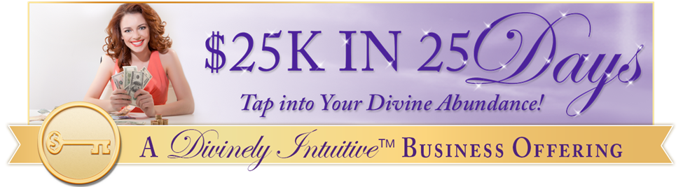
“I don't deserve to have a lot of money!”
Day #21 - Tapping Transcript

Disclaimer: This transcript has been edited; however, there may be English or grammatical errors since it is spoken English, as opposed to written English. Please ignore the errors (or let us know where they are so we can correct them). Enjoy!

Let’s declare our intention…

Let’s call in our guides and call in our angels.

And so, we say “Thank you, thank you, thank you” for this time together,

This opportunity to create our world anew,

This opportunity to create our lives.

Thank you for this opportunity to understand more fully who we are and how we show up in the world,

And what we are here to do,

And the way in which we are here to do it.

We are grateful.

We know that only love is spoken here.

We are thankful for the awarenesses and the “ahas.”

And so, we say “This is so.”

Let’s start tapping…

Even though I have this belief on some level that I’m just not good enough,

I have a belief that I don’t deserve to have all the wonder,

The wonderfulness, the joy, the beauty, the health, the abundance in life.

I somewhere picked up this belief.

And even though I have it in me somewhere,

Somehow, I love myself.

I truly, deeply love myself.

I love that I am always and forever connected with the Divine.

I love that I am strong and capable.

I love that I have made it through many, many things.

I love that there is life around me that I can pay attention to and appreciate and experience.

I love that I have this connection with the Divine,

That I have this connection with my intuition,

That I have this connection within myself, to the world around me.

I love that I’m smart,

That I’m capable,

That I understand bigger picture things.

I love that I understand nuances.

I love that I’m smart,

That I’m intuitive,

That I receive all kinds of wonderful information.

I love that I have the ability to understand things that at times, I didn’t understand.

I love that I’m here bringing my work into the world with passion, with joy, with conscious awareness, with grace.

And even though there are times in my life when I do not feel good enough,

When I get triggered when I feel like I should not be bringing my work to the world because “Who’s going to hire me?”

“Who’s going to buy this?”

“Who’s going to pay me?”

“I’m not worthy.”

“I don’t deserve.”

Even though I have these thoughts,

And I have these beliefs that pop up,

I know they are not true.

At the moment they feel like they’re true.

But on some level, some level, deep within my awareness,

I know they are not true.

In those moments, I call upon my angels to help me clear the path,

To help me clear the misunderstanding,

To help me clear the belief that says “I’m not enough.”

“I’m not worthy.”

I let it go.

And I claim the truth of my being.

I claim who I truly am.

That of Divine connection,

That of a child of the Divine,

Always connected.

Always connected to the world around me.

Always aware.

Always.

I let go of the stuff in my head that says “No. you’re not.”

“Who do you think you are?”

“You can’t do that. You’re not good enough.”

“Look what you did in the past. Look what you said. Look how you behaved.”

“You don’t deserve.”

I let go of the shame that binds me to the past.

And I call forth the truth of who I am,

To be seen by myself,

To be aware of,

To be carrying forward with myself.

This stuff that says “I’m not good enough,” is complete and utter BS.

This stuff that says “I’m not worthy,”

That I don’t deserve,

I’m a work in progress.

Of course, I deserve.

And I will continue to be that work in progress.

I will continue to grow.

I will continue to evolve.

I will continue to learn.

I don’t have to get there in order to deserve.

I deserve right now.

I deserve right now.

And I give myself the gift of that knowledge.

I am worthy.

I give myself the gift of forgiveness.

For those who say I am not,

For those who would have me believed that I am not,

Including myself,

I am worthy.

I do deserve.

I can experience abundance and joy and health and wonder in my life,

Just because…

This is my truth.

Anything that is in the way of that truth being my reality,

I let go of and cut the cords from,

And say “Thank you for sharing.”

“You are not my future.”

“I release you.”

“I forgive you.”

“I let you go.”

“I choose a different reality.”

“I choose a different story.”

“I choose a different future.”

And I choose to become aware when I am telling that story within myself.

So that I may claim the truth from this moment forward,

With every bit of my being.

I am worthy.

I deserve.

I am good enough.

I am worthy.

I deserve.

I am good enough.

I am worthy.

I deserve.

I am good enough.

This is my truth always.

And in all ways.

And so, it is.

Go get your Divine ON!

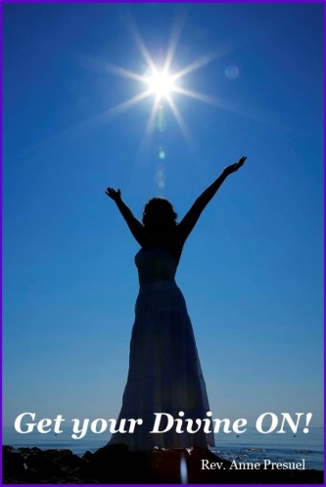

Divine hugs,
Anne

Rev. Anne Presuel
Your 6th Sense Guide to a 6-Figure Business
DivinelyIntuitiveBusiness.com

