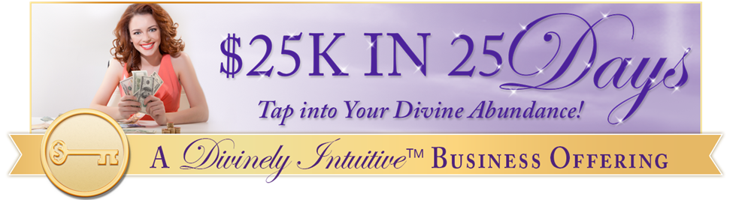

"I deserve lots of money!"
Day #24 - Tapping Transcript

Disclaimer: This transcript has been edited; however, there may be English or grammatical errors since it is spoken English, as opposed to written English. Please ignore the errors (or let us know where they are so we can correct them). Enjoy!

Let’s declare our intention…

Call in our guides and call in our angels and we say “Thank you thank you, thank you” for this gift of time together,

For this opportunity for us to become more aware of what we truly are,

For us to honor ourselves at a deeper level,

For us to own the magnificent beings that we are,

To receive the money, to deserve the money, to realize that we do indeed deserve.

Thank you for the “ahas,” thank you for the guidance, thank you for the love that is provided in this time together and beyond.

We are grateful that it is so.

And so, it is.

Let’s start tapping…

I love money.:

I absolutely, totally love money.

I love the experience of it.

I love the abundance of it.

I love the fact that having it allows me to contribute to other people’s lives.

I love that when I have it, I can contribute to my own life.

I love the fact that when I have it, I can have more of these Divine beings in my sanctuary.

I can have more friends, more generosity, more food for my birds or food for my family.

I can have more.

When I have money, when I allow it in, when I understand the deep true laws of the Divine, of the universe, of allowing and of manifesting,

I can allow more in.

I can say “Yes” without fear.

I can say “I welcome you. I love you. I want to play with you. I want to enjoy you.”

I love that that is an option.

Most of my life, I’ve been told “Money is wrong. Money is bad. Money is evil.”

And I’ve seen many things that have shown me how can evil or used for evil,

Used to hurt someone else,

Used to be grabbing and pulling and harming for more of it.

And money says “That is not my Divine purpose. That is ego’s purpose.”

“I am here to bless you, to bless others.”

“To provide for you beauty and joy and peace of mind.”

And when I listen to money and not my ego, my fear,

When I listen to my heart, when I listen to spirit, when I listen to the truth, I know that money has a Divine purpose in my life.

When I receive it into my being, I know that I’m in alignment with that Divine purpose.

When I say “Yes” to allowing it to show up and show me what it is here for, who it is here for, I bless myself and I bless others.

When I listen to my Divine guidance, I bless myself and I bless others.

I love money.

I love what it can do.

I love that in having it, I can provide something for others.

I can provide someone else’s survival or income.

I can contribute to that.

I can contribute to caring for someone else with love.

I can contribute to someone else’s lifting up and expanding who they are into the world.

When I pay attention and listen, truly listen, money speaks to me and it tells me these,

“I love you.”

“I want to play with you.”

“I want to be a powerful part of your life.”

“I want to be a positive, powerful part of your life.”

“I want to bring you joy.”

“I want to bring you happiness.”

“I want to bring you comfort.”

“I want to bring you peace.”

“I want to bring you connection with others.”

“And the more you have of me, the more of that you can have.”

“Let me in.”

“Let me in.”

“Welcome me with your arms wide open.”

“Let me play with you.”

“Let me help you.”

“Let me support you.”

“Let me gift you.”

“Let me love you.”

“Let me love you.”

And as I listen to money, in treating me, calling me, I realized that I have been pushing it away because of my fears.

And I say “No more. Come in. Welcome!”

“You are my guest.”

“You are my family.”

“You are my friend.”

“Welcome.”

“Thank you for your gift.”

“Thank you for your love.”

“Thank you for wanting to come and play with me, to partner with me.”

“Thank you.”

I welcome it.

I welcome you because I realized that I’ve been closing the door,

I’ve been saying “No.”

I’ve been saying “I’m afraid of you.”

I’ve been saying “You’re not worthy of me.”

And I realized how wrong that is.

I realized that is what I was taught.

And in this moment, I say “No more.”

In this moment, I say “Bring it. Come. Let’s enjoy. Yes, I deserve to play with you.”

I deserve to have more.

I deserve to enjoy.

I deserve to share.

I deserve to have extra to share.

I deserve to know that there is extra to share.

I am willing to see this.

I’m willing to see it.

I let go of whatever unwillingness there may be within me,

Whatever story I may carry,

Whatever belief I may have had,

I let go of that.

I say “Yes” to money.

I say “Yes.”

I say “Yes.”

I say “Yes.”

Go get your Divine ON!

Divine hugs,
Anne

Rev. Anne Presuel
Your 6th Sense Guide to a 6-Figure Business
DivinelyIntuitiveBusiness.com

