Figure-8 Energy Technique
Module 3 Handout

This energy technique comes from Donna Eden, who is a favorite of mine. I use this technique regularly, and I highly recommend you do it, as well.

It allows you to connect with your people or person to blend your energy field with another person’s (or thing, i.e., your Divine Money Partner), gently and easily, so that there is better and clearer communication and connection, and deeper intimacy.

Here’s how to do the Figure-8 energy technique:

Put your dominant hand with the palm facing your belly (solar plexus level). Now move your hand outward and back to you in a figure 8, as though you are describing the ebb and flow of the ocean.

It goes out; it comes in; your arm is reaching out away from you and then coming into you and you’re doing a figure 8 on its side—the infinity symbol.

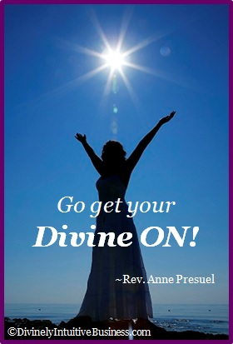
Happy connecting!

Divine hugs,

Anne

Rev. Anne Presuel
Your 6th Sense Guide to a 6-Figure Business
DivinelyIntuitiveBusiness.com

