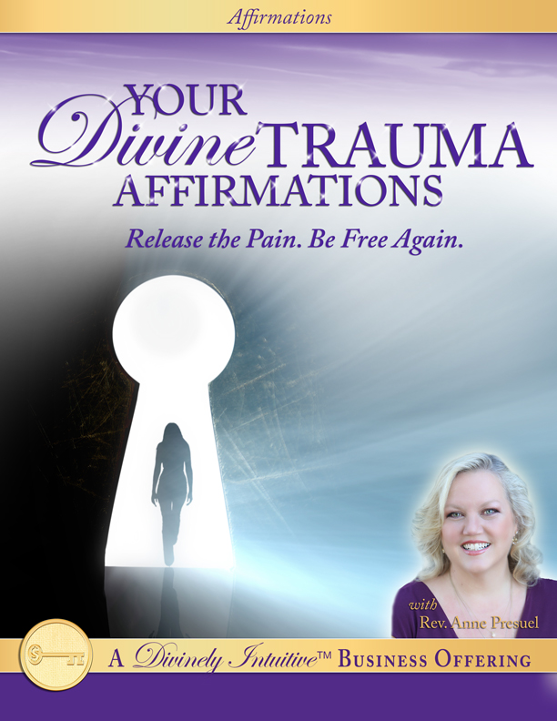
Your Divine Trauma
Affirmations

Hello, Divine One!

Here are your Divine Trauma affirmations. In order for these to be the most effective, you may want to record the ones you really love in your own voice. Edit these to be what you resonate with… the way you think, what you dream of having. Add beautiful music you love.

However, if you prefer to listen to them the way I have created, they are beautiful … and effective.

Notice how your connection with your past experience shifts as you listen to these affirmations. Notice how you respond to things that once upon a time triggered you into feeling sad or angry or helpless. Notice how you shift into a sense of trust that whatever has happened has been for your highest good.

Because as you know: when you change your thoughts and energy, you change the world around you.

Enjoy them!

Take a nice deep breath in…
… and release … and listen (and tap if you feel guided to as I say these words)

I breathe in life.

I breathe in life, that sacred beautiful, holy breath of life.

It flows into my body easily and effortlessly.

I breathe it in deeply…

And I breathe it out.

I breathe it in deep into my body…

Deep into my cells…

Deep into each and every cell of my body…

It brings life to each cell…

This breath brings love to each cell…

It brings hope to each cell…

It brings peace to each cell of my body…

And as I breathe out, I breathe out anything that is hurting.

I breathe out anything that is in turmoil.

I breathe out anything that is heavy.

I breathe out sadness.

I breathe out grief.

I breathe out disappointment.

I breathe out any sense of betrayal and loss.

I breathe out anger.

I breathe out anything that is in any way harming me or my body.

Because right here, right now, in this sacred moment, I breathe in love.

I breathe in understanding.

I breathe in compassion.

I breathe in peace.

And I breathe out anything that is in any way harming me or my body.

And as I continue to breathe in and breathe out, I breathe in the Truth of Spirit…

I breathe in the Love of the Divine…

I breathe in that peace that passes all understanding…

And I breathe out anything that is in the way of this Truth, this Love, this Peace.

I breathe in knowing that I am Love.

I am loved.

I am beloved.

I see love everywhere I look in my life.

It’s everywhere.

And I honor the love that I see.

I trust the love that I see.

I see that I am surrounded by love everywhere I look.

I am surrounded by love in all areas of my life.

I recognize this when I put my attention onto it.

And I watch it grow and expand.

I watch it bring beauty and joy to my life.

And I feel it in my body.

I feel all of the love that I see.

I feel it in my heart.

I feel it in my soul.

I feel it in my mind.

I let this love in, deep into my being.

I know that I am held in the arms of love.

I am held in the arms of the Divine.

I am held in the arms of Love that passes all understanding.

This love from the Divine transforms me.

It moves me from hurt into peace.

It moves me from anger into peace.

It moves me from sorrow into peace.

It moves me from shock into peace.

The love from the Divine transforms me when I allow it.

And I allow it because I trust.

I trust that at the highest level – at my soul level, all is well.

I trust that even though I don’t understand why this has happened, all is well.

I trust that there is a higher reason that I cannot see at this moment.

I trust that this higher reason will be revealed at the perfect time.

I trust… I trust.

I trust that the Divine has my best interests at heart.

And I trust myself to have my highest interest at heart.

Not only mine, but those around me, as well.

I trust that all will indeed be well, and I don’t have to understand it all right now.

I trust.

Today, I choose to be peaceful.

Today, I choose to be calm.

I choose to be serene.

I choose to be kind.

Today, I am peaceful.

I am calm.

I am serene.

I am kind.

I show kindness to everyone I meet.

I bless them as I greet them.

I look for and find something I like about them.

And I hold that in my mind as I greet them.

Doing this brings me peace.

Doing this brings me connection.

Doing this brings peace into my world and peace into the world around me.

Today, I am peace.

I am the peace that passes understanding, because my peace comes from compassion.

I am compassionate.

I am compassionate to myself.

I am compassionate to others.

I am compassionate to all living beings.

I am compassion in action.

I show compassion in all areas of my life.

I show compassion toward everyone and everything I see.

And I extend this compassion to those who are hurting or who are afraid.

My compassion makes it easy for me to put myself in their shoes and to extend love to them.

My compassion helps me to see them through the eyes of the Divine,

Through the eyes of love…

Through the eyes of peace.

Today, I choose to be compassionate toward myself and to others.

I know that by doing this, I bring even more love into my life.

I bring more connection into my life.

I bring more grace into my life.

I bring more peace into my life.

Today, I choose to believe that I am safe…

That I am protected.

I choose to believe that all the help I need - and even more - comes to me at the right time in the right way.

I am safe.

I hold this thought that I am safe, that I am protected.

I hold it with every bit of my being.

And I call in my angels to be here at my side.

I ask them to come, be my protectors, to keep me safe.

They are always at my side whenever I ask.

I feel them there.

I see them.

I recognize them.

Today, and every day, I am surrounded by angels.

My loved ones are surrounded by angels.

We are protected.

We are safe.

My home is surrounded by angels.

My car is surrounded by angels.

My work is surrounded by angels.

My business is surrounded by angels.

My finances are surrounded by angels.

My animals are surrounded by angels.

My land and my water are surrounded by angels.

It is protected by them.

My loved ones’ homes are surrounded by angels.

Their cars are surrounded by angels wherever they go.

Whatever mode of transportation they take, they are surrounded and protected and safe, because the angels walk by their side.

Their work and finances are surrounded by angels and protected.

We are protected by the angelic realm.

Nothing can harm us.

Nothing…

For we are indeed protected.

Knowing this, allows me to know that no matter what happened or what will happen, I can trust in the Divine.

I can trust that I am safe.

I can trust that I am protected.

I can trust that I am provided for.

I can trust that I am loved.

I do trust that I am safe.

I trust that I am protected.

I trust that I am provided for.

I trust that I am loved.

I trust in the Divine.

I know that what has happened will transform not only me, but the world around me.

Good always comes from trauma.

Awareness and wisdom always come from pain, if I will allow it.

And so this day, I say, I choose wisdom.

I choose awareness.

New understanding and clarity are the children of pain and loss.

A deeper connection with the Divine is mine, if I will allow it, if I will accept it.

New levels of compassion are mine, if I allow them in.

New levels of faith are mine, if I say yes.

And so I say “Yes, I trust that good is coming from trauma.”

I trust that my awareness is increased from this experience.

That I am a new being because of it.

More powerful, more aware, more compassionate, more kind, more committed to being that light…

That beautiful, pure expression of light in this world.

Today, I choose to see that.

I choose to see myself with new eyes, through the eyes of the Divine.

I choose a new understanding.

I choose to believe that this situation will not only transform me, but everyone with whom I come into contact.… for the good of all.

I let go of needing to know why this happened…

I let go of demanding to know why …

And instead, I choose to trust.

I trust that I will understand at the right time and in the right way.

I trust that I will be shown.

I trust that when I’m ready, I will see exactly how perfect this situation truly was … and I will understand why.

But until then, I trust.

I let go of cynicism and despair.

And I step in to trust and faith.

I believe that which brings joy and light into my life, I do not need to choose despair.

I choose wisdom,

I choose enlightenment,

I choose awareness,

I choose compassion.

I believe and I see how this situation is bringing new opportunities, new connections and new experiences for my life, for my business, for my finances, for my relationships… and for the good of all.

I believe that this is true.

I choose clarity.

I choose to see how this is true.

Today, I choose a deeper connection with the Divine.

I allow my intuitive guidance to lead me, to show me the way.

Today, I get quiet and I connect within.

I connect with my own deep Truth.

And I honor that Truth.

I know that it will show me the way that I am to go.

I know that by following that, my deep inner guidance, that I will experience miracles in my life.

I will experience miracles in my business.

I will experience miracles in my finances, in my health, in my relationships.

I know that by following my Truth, the perfect people will be placed in my path at the right time, and in the perfect way.

I know this to be true.

I choose to stand in faith, to stand in trusting that this is true.

And I allow the light of the Divine to shine in me and through me into all areas of my life, and into the lives of others.

I am an open channel for that radiant pure light of the Divine to move into this world, because I AM that pure, beautiful, radiant expression of the Divine in this world.

I trust this. I believe it. I hold onto this truth.

And I live my life as though it were.

And I live my life in connection with those around me, with the Divine, with nature, with all beings.

And it is a connection of

- perfect wholeness,
- perfect oneness,
- perfect peace,
- perfect joy,
- perfect calmness,
- perfect compassion,
- perfect grace,
- perfect health and
- perfect wealth.

I live my life in alignment with all of these and I say thank you, thank you, thank you, thank you…

Thank you to the Divine.

And so it is. And so it shall be, now and forevermore. Amen.

Thank you for showing up.

Thank you for being willing to be that light that shines so brilliantly in the world at this time.

Thank you for being here, for being that perfect, pure, holy expression of the Divine in this world.

You are magnificent.

You are perfect just the way you are.

You are truly Divine.

Nice deep breath. Thank you for being here. Big hugs to you.

Now go get your Divine ON!

Divine hugs,

Anne

Rev. Anne Presuel
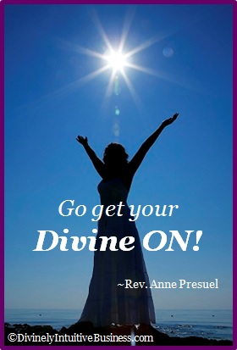
Your 6th Sense Guide to a 6-Figure Business
DivinelyIntuitiveBusiness.com

