Your Divine Intention
Week 1 Handout

Hi, Divine One –

For this program, let’s begin by setting our intentions for what we want to create in our month together. The clearer you are now, the easier it will be to recognize that you created what you intended later.

For example, if you want to create more money, then please specify how much money you want to create. If you want to create more clients, then please specify how many clients you want to create. You get the idea.

Be tangible. Be specific. Here are some examples below:

- I intend to create 3 new clients in this next month.
- I intend to connect successfully with my market in this next month via my ezine/social media platform/my list, etc.
- I intend to create $5,000 in income in this next month.
- I intend to become more visible to the world this next month by creating and sharing 5 videos/articles/blogs, etc.
- I intend to get more organized in my business in this next month by creating an Operations Manual.
- I intend to be more comfortable with sales conversations in this next month by having 20 more.
- I intend to create a new social media marketing campaign by learning and becoming active (in a marketing way) on a new (to me) platform. The platform is _______.
- And so on.

We will be filling this form out on our first call. After you have filled it out, please send it to me at Anne@DivinelyIntuitiveBusiness.com so that I know what we’ll be holding the space of creation for, and so that when we are on our connection call, I will know what you’re working on.

With that said, here are your questions:

- I intend to create the following during the Divine Coaching Circle:

- I will know I have created it because:

- The 3 things I know I need to do in order to create this are:

a)

b)

c)

- What has gotten in the way in the past that caused me to not do this successfully is:

- I am willing to do them now because:

- The reason I want this is:

- I think I can’t have it becaue:

- I think I can have it because…

- Because I intend to create the above, I commit to be or do the following during the Divine Coaching Circle program:

If you have anything else to add, please do so below:

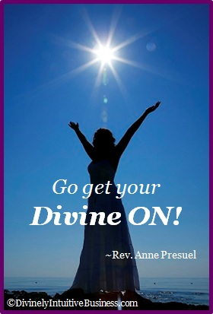
Divine hugs,

Anne

Rev. Anne Presuel
Your 6th Sense Guide to a 6-Figure Business
DivinelyIntuitiveBusiness.com

