Divine Diamond Program

The Divine Diamond program is a unique, one-of-a-kind coaching program that provides training, support, and mindset/energy shifts for entrepreneurs whose work is distinctive, hard to explain and very Divinely-guided: healers, coaches, intuitives (psychics and mediums), energy therapists (EFT practitioners, Reiki therapists, Theta healers, Eden Energy therapists, Barbara Brennan therapists, etc.), holistic and alternative therapists, ministers, shamans, angel therapists, animal communicators, and so on.

This program is designed to help you understand how to build your business. You’ve spent years developing your gifts; now it’s time to learn how to offer them in a way that will support you with a sustainable, abundant business.

Here are the specifics of this yummy program…
Your Divine Diamond Program Details

2 40-minute private one-on-one sessions with Anne per month
3 Deep-Dive Planning Sessions (90 min) with Anne -1 every 4 months
Open Office Hours – 15-Minute Laser Coaching Session
2 Emergency “I need help!” sessions per year
Divine Diamond only Q&A Calls – 2 90-minute calls/month
Divine Diamond only Tapping Calls – 2 90-minute calls/month
Divine Diamond only 3-Day Retreat
Exclusive email access to Anne
Exclusive, Divine Diamond Online Community
Divine Diamond Program Trainings

Divine Manifesting Circle – year-long program ($924)
Divine Business Club – 5 years of Divine Business Club trainings (Value $3,000+)
Create Your Divine Brand – 5-week home study course ($397)
Create Your Divine Offer – 5-week home study course ($397)
Sacred, Sexy Sales – 8-week home study course ($597)
Your Divine Biz JV Giveaway – 7-week home study course ($397)
4 Clients in 4 Weeks – 4-week program – when offered (priceless!)
Divine Client Attraction – 6-week home study course ($397)
Plan Your Divine Year – 4-week home study course ($197)
Tap into Your Divine Money – 4-week home study course ($222)
Build Your Divine List – 6-weeks – when offered 2020-2021 ($397)
$25K in 25 Days - 4-weeks – when offered 2020-2021 (priceless!)
25 Clients in 25 Days – 4-weeks – when offered 2020-2021 (priceless!)
Other Training Programs – as offered to Anne’s Divine Community
Your Divine Energy Support

Divine Biz Angel Cards, $25 value
Your Divine Business Affirmations, mp3 & pdf $77 value
Divine Client Attraction Affirmations, mp3 & pdf $77 value
Successful Sacred Sales Affirmations, mp3 & pdf $97 value
Divinely Intuitive™ You Affirmations, mp3 & pdf $77 value
Create Your Divine Offer Affirmations, mp3 & pdf $77 value
Unlimited Wealth Affirmations, CD, mp3 & pdf $47 value
Radiant Health Affirmations, CD, mp3 & pdf $47 value
Divine Client Attraction Heart-to-Heart Guided Visualization
Other Affirmations & Meditations as offered
Your Divine Community Connection

Divine Diamonds Online Community - Priceless
Divinely Intuitive™ Business Online Community - Priceless
Other Divinely Intuitive™ Business Program Communities - when offered
Your Divine Bonuses

Fast-Action Bonus
Divinely Intuitive™ Business Reading
To qualify, you must decide within 24 hours of your Ignite Your Divine Business session
Value - $497
Solo Email from Anne to her 14,000+ person list
(When ready in a launch)
Value – Priceless!

Your Divine Diamond Trainings

Divine Business Club

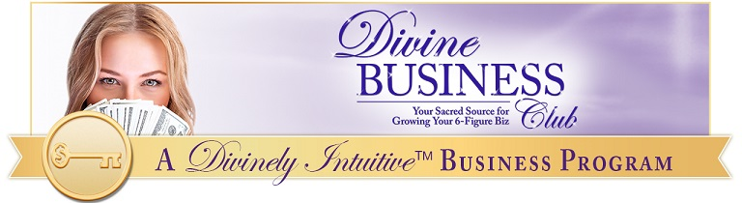
Divine Diamonds get access to the entire library (5 years’ worth!) of the Divine Business Club. You can see that list here:
http://divinelyintuitivebusiness.com/divine-trainings

Create Your Divine Brand
https://CreateYourDivineBrand.com
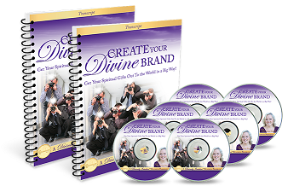
This 5-week training teaches you how to create a Divine brand – one that is recognizable, trusted, and authentic to you!

Your business starts with your brand. Create one that is inspiring to you and your clients. This program will help you do that.

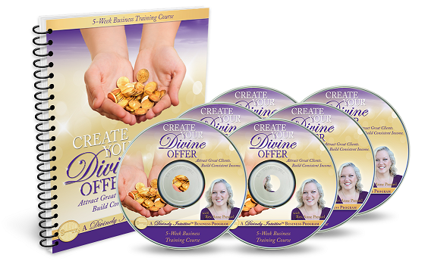
Create Your Divine Offer
https://CreateYourDivineOffer.com

This 6-week training teaches you how to leave the dollars-per-hour business model behind.

You’ll learn how to create a powerful offer for your services that will give you steady, consistent income and clients you love working with.

4 Clients in 4 Weeks
https://4Clients4Weeks.com

This little 4-week program has proven to be one of Anne’s most popular programs.

In it, you’ll learn how to connect with your prospective clients … in a way that feels easy and fun to do.

Many people have said this was a game-changer for them in their business!

Divine Client Attraction
https://DivineClientAttraction.com
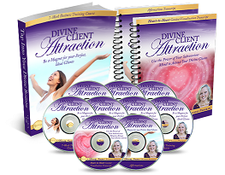
Divine Client Attraction is a 7-week training teaching you how to be attractive to your ideal clients.

You’ll learn strategies to make yourself more client attractive, and you will also learn energy techniques to engage with your clients on a deeper level (sometimes before you ever meet them!).

Sacred Sexy Sales
https://SacredSexySales.com

This 8-week training course will teach you how to have a sales conversation with your prospective clients - with integrity, authenticity, and most of all, without feeling salesy.

It will help you understand how your sales conversations can come from a place of service and deep connection.

Your confidence will significantly increase as you understand how powerful these conversations can be for your people.

$25K in 25 Days
https://25K25Days.com
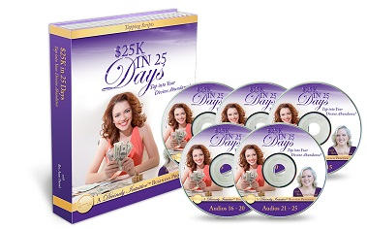
This 5-week tapping intensive will help you clear out the fears and concerns you may have about your ability to create an abundance of money in your business (and your life)!

By participating in this program, you will discover a whole new level of money magic!

Money wants to play with you and this program will help you open the door to letting it in!

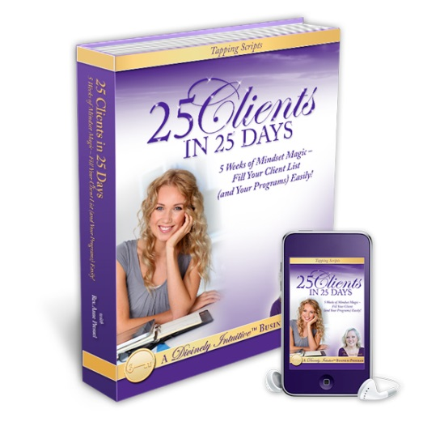
25 Clients in 25 Days
https://25Clients25Days.com

This 5-week tapping intensive will help you clear out the fears and concerns you may have about your ability to create all the Divine clients you want in your business!

You’ll uncover your own areas of resistance to creating and receiving an abundance of clients. (It will surprise you!)

Tap into Your Divine Money
https://TapIntoYourDivineMoney.com
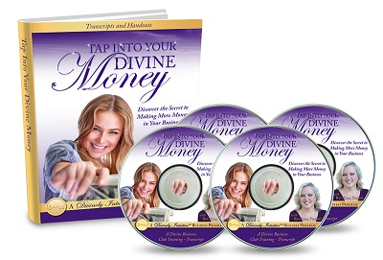
This 4-week training course will help you discover the secret to making more money in your business. It is filled with not only teachings on how to change your relationship with money, but the energy tools to be able to do that.

You’ll discover that money wants to play with you; it wants to come to you! And you’ll learn how to let it do just that.

Your Divine Biz JV Giveaway
https://yourdivinebizjvgiveaway.com/small-gifts-big-difference/
This 7-week program will help you get ready to be a joint venture (JV) partner – whether in a JV giveaway or any other joint venture.

You will understand how to create a yummy offer and what to do with it. In addition, you will learn what it takes to be a good JV partner, so that you can be invited again and again.

Plan Your Divine Year
https://PlanYourDivineYear.com
This 4-week program will lay the foundation for a truly Divine year. You will create not only your vision for your upcoming year, but also a plan for that vision.

This program includes the exact ritual Anne uses each year to create her new year. It offers energy clearings as well as a visualization that will connect you with your Divine vision so you can create your Divine year!

Other Divinely Intuitive Business™ Programs

In addition to the above trainings, the following trainings will be offered in the future to the general public. All DIB programs (excluding certification programs) are included in the Divine Diamond program for as long as you are a participant.

- Build Your Divine List
- Divine Money Club

Divine Diamond Retreat

All Divine Diamonds can attend a live, 3-day retreat held in May each year.

Many Diamonds have said that attending the retreat was the biggest part of the Diamond program that transformed their business.

At each retreat, each Diamond will receive a “hot seat.” This is a time where the entire group is focused on them and their business.

Many Diamonds have gotten very clear about some – or all – of the following in their hot seats:

- Their brand,
- Their target market,
- Their message,
- Their offer,
- Their sales skills,
- Their mindset,
- Their marketing strategy,
- and so on.

In addition to a power hot seat experience, you will participate in sacred rituals and lots of tapping each day.

Divine Diamond retreats are fun, powerful and very transformative experiences that you never regret having!

Divine Diamond Energy & Mindset Support

Tap into Your Divine Business
http://divinelyintuitivebusiness.com/tiydb-2
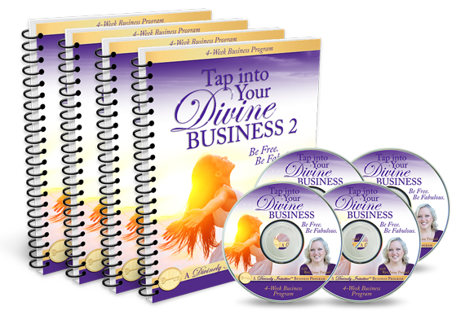
This 4-week program offers tapping support and training in 4 areas: your money, clients, your offerings, and your marketing.

You’ll understand more fully how to build the business of your dreams, and you will clear many of your energetic blocks.

Your Divine Business Angel Cards
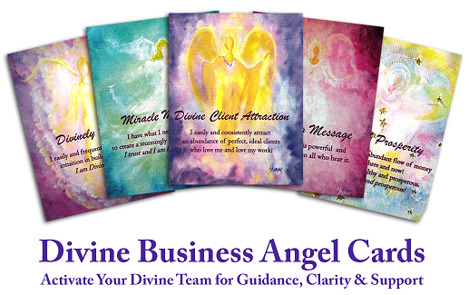

This set of 22 angel cards can be used for offering readings, and they can be used as daily inspiration.

Some people use them when they are challenged in a specific area in their business. They find the angel card reminds them of the truth: they CAN build their Divine business and make it an abundant, sustainable one!

Your Divine Business Affirmations (bundled below) – mp3 and pdf format

Your Divine Biz Bundle 1 includes:

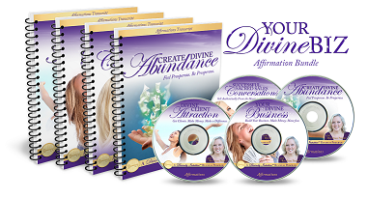
Create Divine Abundance
Divine Client Attraction
Your Divine Business
Successful Sales Conversations

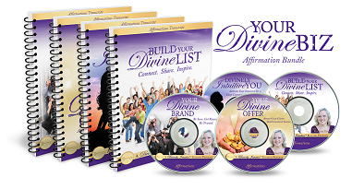

Your Divine Biz Bundle 2 includes:

Build Your Divine List
Your Divine Brand
Your Divine Offer
Build Your Divine List

For more information about any of these programs, please visit the Divinely Intuitive™ Business Store at http://divinelyintuitivebusiness.com/divine-store
Divine hugs,

Anne

Rev. Anne Presuel
Your 6th Sense Guide to a 6-Figure Business
DivinelyIntuitiveBusiness.com

