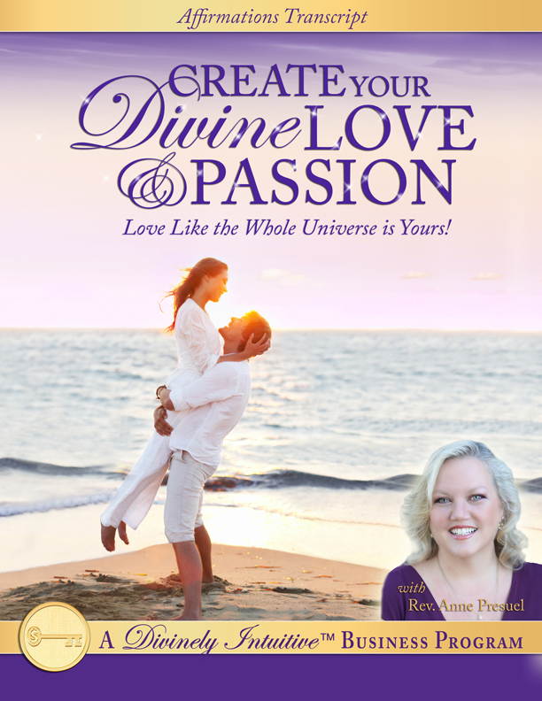
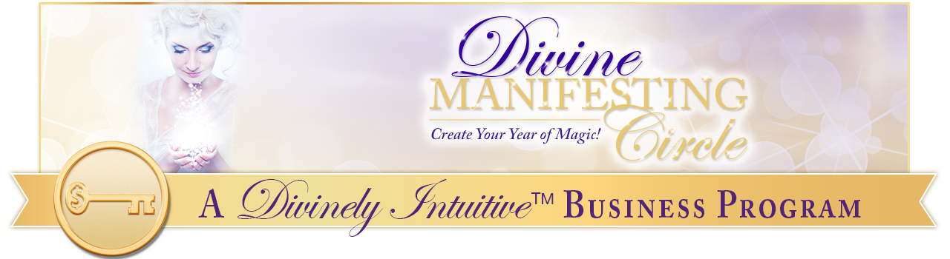
Create Your Divine Love & Passion
Affirmations

Hello Divine One!

Here are your Love & Passion affirmations. In order for these to be the most effective, you may want to record the ones you really love in your own voice. Edit these to be what you resonate with… the way you think, what you dream of having. Add beautiful music you love.

However, if you prefer to listen to them the way I have created, they are beautiful … and effective.

Notice how your connections with others deepens and grows as you listen to these affirmations. And then notice how you respond to your friends, your partner or spouse, your children, and your clients. Notice how the world around you becomes more loving, more kind and more joyous.

Because as you change your own thoughts, you change the world around you.

Enjoy them!

I am so in love with life.

Every day, in every way, my life is growing more and more in love.

My life is filled with love.

I love to breathe in the fresh air.

I love to listen to the birds sing.

I love to laugh out loud.

I love to feel Spirit’s breath.

I love to hear Spirit sing.

And I want to revel in the joy I experience just simply by being alive.

I am so grateful that I have life.

I am so grateful that I have love in my life and love for my life.

I am so grateful that I have delight in my life and delight for my life.

I am so grateful that I have happiness in my life and happiness for my life.

I am so grateful that I have wonder in my life and wonder for my life.

And I am so grateful that I have beauty in my life and beauty for my life.

I am so grateful that I have satisfaction in my life and satisfaction for my life.

I am so grateful that I have life.

I am so grateful for the ones I love who are sharing my life.

And I am so grateful for God and for God’s love.

Thank you, God. Thank you, God. Thank you, God.

Perfect love comes to me now in all ways, always.

I open myself up to this perfect love gently and easily.

This perfect love comes from God.

It comes through me.

And it comes through those around me.

I am open to Spirit’s perfect love in every moment of every day.

And I shine it forth into the world around me.

Love touches my life in all ways.

It touches my heart.

It touches my mind.

It touches my body.

It touches my very being.

I am able to fully express myself lovingly in all ways, for I am God’s great love in expression.

My life is a monument to God’s beautiful love.

I am willing and I am able to be loving and happy.

I am willing and I am able to be tender and caring.

I am willing and I am able to be gentle and compassionate.

I am willing and I am able to devoted and joyful.

And I am willing and I am able to be enchanting and blissful.

Great love is here in my life now.

Deep love is here in my life now.

Magnificent love is here in my life now.

Profound love is here in my life now.

Sacred love is here in my life now.

Unconditional love is here in my life now.

God’s love is here in my life now.

I am bursting with energy and light.

I am bursting with love and delight.

I am bursting with joy and happiness.

And I am bursting with wonder and beauty.

This is an abundant universe with plenty for all.

I now claim my portion of love, of joy, of peace and of abundance.

Today will go exactly as I intended to.

I can and I do create a wonderful day, a wonderful day each and every day.

I feel alive for I allow myself to experience the life of God.

I feel loving for I allow myself to experience the love of God.

I feel wonderful for I allow myself to experience the wonder of God.

I feel content for I allow myself to experience the contentment of God.

I feel satisfied for I allow myself to experience the satisfaction of God.

I feel beautiful for I allow myself to experience the beauty of God.

I feel glorious for I allow myself to experience the glory of God.

And so it is.

Only good things come in to my life now.

I have nothing to fear.

I have all the love I need and I can create all the love I want.

I am creating all the love that I want.

I receive the perfect love of God in my life now.

Everything in my life is a reflection of this wondrous love.

I’m willing to give up what I have been and to give up thoughts I’ve created what I have been for the love that I’m now creating.

I am a radiant, magnetic being in all ways.

I draw to me this perfect love here and now.

I am clear about my vision for my life and for my love.

And in this clarity, I discover a freedom of being that until now I had only imagined.

My clarity brings focus and joy to my life.

I am clear about my life, about love, and about my next steps.

I attract joy into my life with effortlessness and ease.

I attract bliss into my life with effortlessness and ease.

I attract happiness into my life with effortlessness and ease.

I attract delight into my life with effortlessness and ease.

I attract pleasure into my life with effortlessness and ease.

And I attract love into my life with effortlessness and ease.

I attract everything I desire into my life with effortlessness and ease.

I’m made for love, for joy, for peace, for health and for abundance and I am now experiencing these in ever increasing degrees in my life.

Thank you, God.

I know that unseen, loving energies always support me in everything I do.

And I am always supported by these energies.

I am all I can be at every moment of everyday.

I am always guided by Spirit.

I am always provided for by Spirit.

Perfect love is provided to me by Spirit.

Perfect joy is provided to me by Spirit.

Perfect delight is provided to me by Spirit.

Perfect bliss is provided to me by Spirit.

Everything in my life is provided to me by Spirit.

God is the source of all my bliss, all my love, all my happiness, and all my delight and I am connected to this source at all times.

Perfect love is my birthright.

Dazzling joy is my birthright.

Delicious delight is my birthright.

Profound intimacy is my birthright.

Remarkable satisfaction is my birthright.

Sacred love is my birthright.

Abundant pleasure is my birthright.

Wondrous enchantment is my birthright.

I claim my birthright here and now.

Thank you, God.

In love, I am discovering that I am guided by Spirit in all ways.

Therefore, I always know what to say in all situations.

I easily follow my inner guidance because I know it will take me to the right places at the right times and to the right people.

I trust my intuition more and more each day for I know it guides me perfectly and completely.

I am easily and consistently contented and satisfied with my life.

And I am easily and consistently contented and satisfied with those who share my life.

I’m very contented and satisfied with what I see in my life.

And I’m very contented and satisfied with what I create in my life.

I’m easily and consistently contented and satisfied with everything in my life.

It is safe for me to give love and to receive love for I now draw into my life only those who have my highest good in their hearts.

I’m fully open and fully receptive to the unseen loving energies of the universe helping me with every step of creating my life, of creating my love, of creating my joy, and creating my happiness.

I am an open channel for God’s good to come to me now.

I allow God’s light to flow through me.

I love feeling God’s light.

I love being God’s light.

I am God’s light.

And I bring God’s light into each and every situation I create.

I am inspired by love to be loving.

I am inspired by love to be to be caring.

I am inspired by love to be compassionate.

I am inspired by love to be gentle.

I am inspired by love to be tender.

I am inspired by love to be thoughtful.

I am always supported by Spirit.

I am always guided by Spirit.

And I am always provided for by Spirit in all ways, always.

I immerse myself in Spirit’s love.

I play in Spirit’s love.

I bask in Spirit’s love.

I delight in Spirit’s love.

I relish Spirit’s love.

I savor Spirit’s love.

I am so grateful for Spirit’s love.

Thank you, God. Thank you, Spirit.

I am growing more and more blessed each and every day.

I am growing more and more blissful each and every day.

I am growing more and more luminous each and every day.

I am growing more and more alive each and every day.

I am growing more and more delightful each and every day.

And I am growing more and more loving each and every day.

I am able to create all of these experiences and all of these states of being as I connect to the source of each and every one of them.

I grow in each of these experiences of being as I grow in my connection to Spirit deeply and beautifully.

I feel happy.

I feel fabulous.

I feel amazing.

I feel incredible.

I feel blissful.

I feel light-hearted.

I feel like I can do anything.

I am wonderful.

I am beautiful.

I am happy.

I am fabulous.

I am amazing.

I now attain my goals easily and quickly.

I’m very happy to now give up what I have been for all the love, all the joy, and all the delight I am now creating in my life.

Perfect love is here in my life now.

I see it in the faces of everyone and everything around me.

I am love.

And I am perfect, whole and complete just the way I am.

I am radiant with love.

I am shining with love.

I am beaming with love.

I am splendid with love.

I am dazzling with love.

I shine this love into every area of my life and into every area of my being.

May you be blessed as you bless those around you.

xoxoxo,

Anne

Rev. Anne Presuel
Your 6th Sense Guide to a 6-Figure Business
DivinelyIntuitiveBusiness.com

