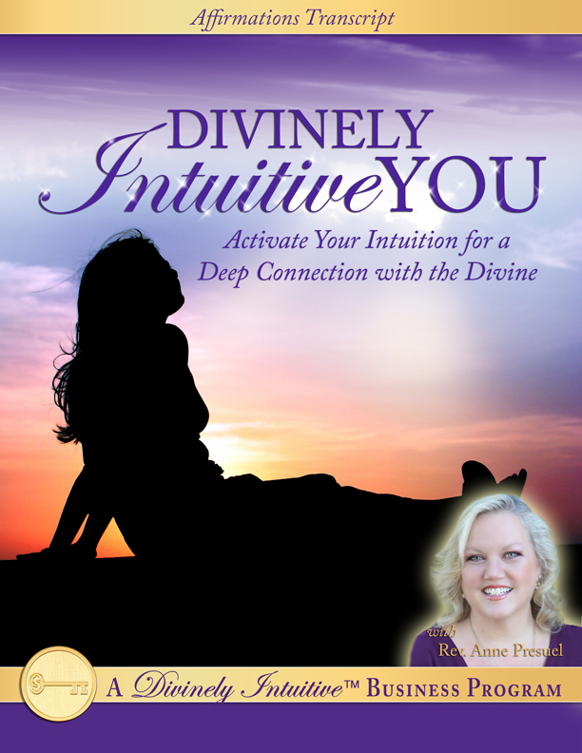
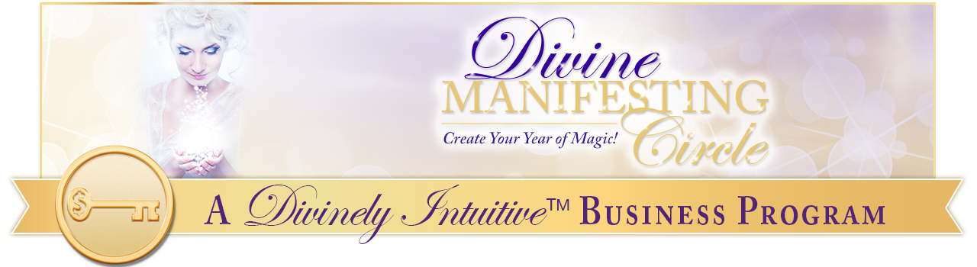Divinely Intuitive™ You
101 Intuitive-Igniting Affirmations

- I am connected deeply within.

- I know that I have all the answers I need inside me.

- I can access these answers anytime I desire.

- I know that I have been given all that I need to be able to get whatever answers I desire.

- I deeply and completely love and trust my intuition.

- I love knowing that I can connect to my Divinely Intuitive™ self at any time, and in any place.

- All I need do is get quiet and go within to receive all the answers I need … and want.

- I trust my inner guidance and I take prompt action upon it.

- I know that it is through trusting my guidance and through taking action upon it that my next steps are revealed.

- I easily receive guidance from the Divine.

- I easily trust the guidance I receive from the Divine.

- I have deep faith that I am guided by the Divine in all ways, always.

- I take good care of my body.

- I trust my body and my body trusts me.

- My body is a sacred vessel in this lifetime experience.

- I honor my body and my body honors me.

- I give my body what it needs to be healthy and whole.

- I am aware of the importance of grounding my energies on a regular basis.

- I take care to consistently ground myself, particularly after working with clients or being around crowds.

- I love to feel the earth beneath my feet. I love to feel my excess energy release back into the earth as I bring myself into this present moment.

- I allow myself to get present to my body and to its needs. I listen to my body and I take good care of it throughout the day.

- I am clear that it is through being sure that my energy is flowing that I am able to stay fully present to this perfect moment in time.

- I consistently pay attention to how balanced and grounded I am, in each and every situation.

- I know that by accessing my creative energy I am also helping to maintain my connection to the Divine.

- I love being open to the many ways my intuition speaks to me.

- And I am clear about the many ways my intuition speaks to me.

- I think only positive thoughts. I know that the way I think affects my ability to receive information from Spirit.

- I choose to see things from a positive perspective.

- I always view situations in the best possible way I can.

- I choose to see people and situations through the eyes of the Divine. Therefore, I choose to see through the eyes of love.

- I choose to hear through the ears of love.

- I choose to speak with love.

- I choose to think with love.

- I AM Love!

- I feel the Love of the Divine flowing through me in each and every way, all throughout each day.

- This love deeply connects me with my intuition.

- I am powerfully connected to my intuitive abilities.

- And I am grateful that I can deepen my intuitive abilities any time I desire.

- And I am very happy that I can strengthen my intuitive abilities at any time I choose.

- I love having these incredible intuitive abilities!

- I am deeply connected to my intuition.

- My ability to see clairvoyantly is growing stronger and stronger each and every day.

- Every day, I allow my third eye to open more and more so that I can receive clairvoyant visions.

- I know that I can open and close this energy center any time I choose.

- I choose to see clairvoyantly!

- My ability to hear clairaudiently is growing stronger and stronger each and every day.

- Every day, I allow my ear and throat chakras to open more and more so that I can hear my truth and speak my truth, whenever I need to, and whenever I want to.

- I choose to hear clairaudiently!

- My ability to know claircognizantly is growing stronger and stronger each and every day.

- Every day, I allow my crown chakra to open more and more so that I can receive clear information to help me understand not only the world around me, but to also understand clearly what my next right steps are.

- I choose to know claircognizantly!

- My ability to feel clairsentiently is growing stronger and stronger each and every day.

- Every day, I allow my sacral and heart chakras to open more and more so that I may receive information into my being through my connection to my body.

- I choose to feel clairsentiently!

- I am aware that by using all of my energy centers, I am allowing Divine information to flow to me and through me.

- I am clear in all areas of my life. I love clarity! I thrive on clarity.

- I am organized, neat and clean in my office, in my home and in my life.

- I know this organization and this order allows me to get quieter deep within my being.

- And it is from this quiet that I receive all the information I need from the Divine.

- I am easily able to understand all the information I receive.

- I am willing to be patient as I receive the information I need from the Divine.

- Even more, I am willing to be patient in understanding the information I receive from the Divine.

- I am completely loved by the Divine, and I feel this truth deep within my being.

- I know that I am here to serve those who are in my life, and that I am the pure expression of Divine Love to those with whom my work serves.

- I am clear that it is through serving others in my life that I open myself to the abundance of the Universe.

- I feel this wisdom deep within my being.

- I am grateful for this pure and beautiful Divine wisdom.

- I am grateful for the conscious understanding that accompanies this wisdom.

- I receive great abundance from the Divine right here, right now, and I am deeply grateful!

- Today, I feel the grace of the Divine touching my life.

- Today, I know the beauty of the Divine touches my life.

- Today, I hear the Divine speak in many, many ways.

- And today, I am open and receptive to all the Divine offers to me at each juncture.

- I am clear when I am with someone who is not good for me or when I am in a situation that is not good for me. When this happens, I think loving thoughts and surround myself with light.

- I know that by my taking this protective measure, I ensure my own deep connection to the Divine.

- I am always protected by the Angels who surround me.

- I never walk alone.

- I am always guided by loving beings, in all ways, always.

- I always surround myself and my loved ones, our homes and our cars with the pure Light of the Divine.

- I know we are watched over and guided in every move we make by these loving beings.

- And I am deeply grateful.

- Today, I am a clear channel for the Divine. It is easy for me to be this clear channel.

- Today, I see clearly.

- Today, I hear clearly.

- Today, I know clearly.

- Today, I feel clearly.

- Today, I AM Clear!

- I know the difference between my ego and the inner promptings of the Divine. And I follow the inner promptings of the Divine easily and quickly.

- Today, I stand strong in the presence of the Divine and I know that I am safe, that I am loved, that I am strong, that I am whole, that I am pure, that I am provided for, that I am at peace and that I am guided.

- I am clear that each of these gifts is mine for the taking, and that it is up to me to say “Yes!” to them.

- Today, I say “Yes!”

- Today, I say “Yes!” to the Divine!

- Today, I say “Yes!” to my connection to the Divine.

- Today, I say “Yes!” to my connection to the world around me, to the people around me, to life itself!

- And today, I say “Yes!” to my abundant, powerful, amazing future.

- I know I am shown each step of the way, and I trust myself to understand these steps and to take them as they are given.

- Today, I am held up high by the Divine. Today, I am guided by the Divine. And today, I trust this guidance, as I move throughout my day.

- And in each and every situation, I know that this love and support is offered to me.

- Today, I accept the love and support offered to me by the Divine.

- And I am deeply grateful.

- Thank You, God! Thank You, God! Thank You, God. And so it is. And so it shall be. Now and forever more. Amen.

Enjoy these affirmations. Either listen to them on the mp3, or create a recording of them in your voice, which is very powerful.

Affirmations are very powerful declarations. They will help you ignite your intuitive abilities, easily and gently.

xoxoxo,

Anne

Rev. Anne Presuel
Your 6th Sense Guide to a 6-Figure Business
http://DivinelyIntuitiveBusiness.com
