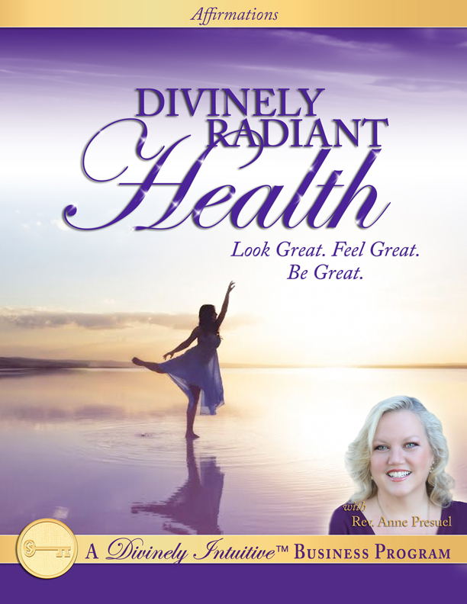
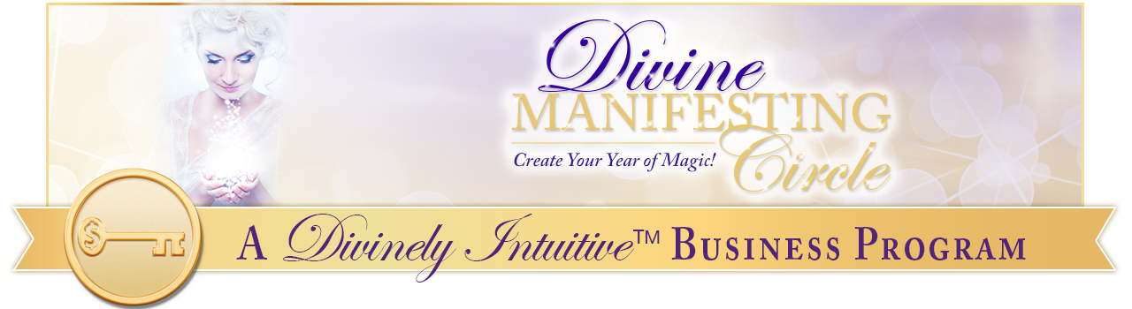Divinely Radiant Health
Affirmations

Every day, in every way, I am growing more and more healthy, beautiful and radiant.

I draw radiant health to me easily and effortlessly.

God is the source of all my radiance and I am connected to this Source at all times.

Divine Perfection is manifesting in my health here and now in magnificent ways.

My vision of my radiant health is that of beauty, strength and perfection.

My body knows how to heal itself.

It knows how to balance itself.

It knows how to be radiant, perfect health itself.

I trust my body to do what it needs to do to attain and maintain ideal health.

I am interacting with life joyously, healthfully, abundantly and peacefully.

I am soooo grateful for my beautiful body.

I am so grateful for my strong body.

I am so grateful for my perfect health.

I am so grateful for my radiant health.

I am so grateful for life itself. Thank you, God!

I am conscious, mindful and insightful in all areas of my life.

I am happy, alive and vibrant in all areas of my life.

I am clear, focused and determine in all areas of my life.

I am peaceful, gentle and patient in all areas of my life.

I think only peaceful, loving thoughts about my body and about my own life.

I fill my life with these thoughts, and my actions move into easy and gentle alignment with each and every one of them.

I am filled with the life and health of God in all areas of my life.

I am delighted with my body and my body is delighted with me!

I ask and I allow my body to attain and maintain perfect balance.

I ask and I allow my body to attain and maintain perfect health.

I love eating foods that support my body’s ideal health.

Fruits and vegetables taste delicious to me. I now eat them in perfect quantities and varieties to meet my body’s needs.

I eat only enough to satisfy my hunger.

I always know when to stop.

I listen to my body’s signals all the time.

I know when I am satisfied and it is easy for me to stop eating when I am satisfied.

It is easy for me to eat appropriate portions of food.

I love to chew my food thoroughly and completely.

I know this supports my body’s digestion.

I trust my body’s wisdom to guide me in my food and exercise choices.

I know move into a deeper, more trusted and more loving relationship with my body and with my health.

I love to exercise and to move my body.

I know that this supports me in creating radiant health.

I love to stretch my body.

I love to feel my body.

I love to be in my body.

My body is fluid and flexible.

My joints move easily and smoothly.

My muscles are strong and limber.

My bones are strong and healthy.

They know how to stay in alignment.

My organs are strong and healthy.

They receive all the light, all the love, all the oxygen, and all the nutrients they need to maintain ideal health.

My skin is clear and glowing.

It is growing more and more youthful each and every day.

I have all the energy I need and I can create all the energy I want!

I know how to do this for I know that all energy comes from God and I am connected to this source at all times.

I now let go of any fears I may have regarding my ability to create radiant health.

I embrace my body’s beauty, its strength and its perfection.

I embrace my health and I know that I can create ideal health as I focus upon allowing the light and the energy and the love into myself and into my very being.

Spirit is the source of all my health and the source of all of my awareness of my health, and I am connected to this source at all times.

I love being healthy.

I love watching my Divinely-inspired ideas move from Spirit into full manifestation in the physical.

It delights me to see these clear, focused ideas come into being.

I trust my body to do what it needs to do to attain and maintain ideal health.

Trusting myself and trusting my body to attain ideal health is easy for me because I am always thinking thoughts of peace, of love, of health and beauty.

I am feeling younger and younger each and every day.

I am feeling happier and happier each and every day.

I am growing healthier and healthier each and every day.

I am growing brighter and brighter each and every day.

I am feeling lighter and lighter each and every day.

I am growing more and more radiant each and every day.

I am growing more and more energetic each and every day.

I am growing more and more alive each and every day.

And I am feeling stronger and stronger each and every day.

I am happy, I am healthy, I am wealthy and I am wise.

I am radiant with the light of God flowing through me.

Divine Love is the one and only reality in my life, and it richly manifests in great health here and now.

Wondrous health comes easily to me.

Radiant, vibrant health is normal for me.

I am made for peace, for love, for health and for abundance, and I am now experiencing them in ever increasing degrees in my life. Thank you, God!

Divine ideas about my ideal, perfect health flow into my life whenever I need them and wherever I am. Thank you, God!

Flourishing health is my birthright.

Radiant health is my birthright.

Lustrous health is my birthright.

Dazzling health is my birthright.

I am a beautiful, magnetic being in all ways.

I know that unseen, loving energies always support me in every endeavor, including perfect health.

I am always supported by Spirit.

I am always guided by Spirit.

I am always provided for by Spirit.

Spirit speaks to me in many different ways, and I am open and receptive to each and every one of them!

I now draw into my life others who are also offering joyous, balanced, vibrant thoughts of health, and, as a result, we discover that we love creating together perfect health, perfect joy, and perfect strength.

It is easy for us to do so, for we discover that we are supporting one another in our health, in our joy and in our strength.

I know that there is an infinitely abundance supply of health in the Universe, and I claim my supply now.

It is safe for me to be healthy, for I draw into my life only those who have my highest good in their hearts.

I have wonderful support in the form of healthcare practitioners who know how best to help my body attains and maintain ideal, radiant health! Thank you, God!

I am fully open and receptive to the magic of the Universe helping me with every step of creating my ideal health.

I am strong… and flexible… and I am sure of myself.

I am grounded and centered in my body.

Great health is easy and comfortable for me.

Magnificent health is easy and comfortable for me.

Wondrous health is easy and comfortable for me.

Ideal health is easy and comfortable for me.

Radiant health is easy and comfortable for me.

Glorious health is easy and comfortable for me.

Dazzling health is easy and comfortable for me.

Thank you, God, for a happy, healthy body!

I allow light to enter into my body on my breath.

I am flourishing with each and every breath I take!

My very breath draws life and health into my body!

I breathe easily and deeply.

Each breath brings into my body sacred life, sacred light, and sacred wholeness.

I am willing and I now choose to receive all of God’s good for my body and my health.

I am balanced in all ways.

My energy flows beautifully and perfectly.

I joyously feed my body good foods and clean water.

I delightfully feed my spirit good thoughts and blissful laughter.

I radiantly feed my mind happy dreams and visions.

I use my God-given abilities to do this easily and consistently.

I take guided actions that are in alignment with my desires and my beliefs and I am clear as to what Divine guidance feels like.

I am an open channel for God’s perfect health and vitality to come to me now.

I allow God’s light to flow through me.

I love feeling God’s light. I love being God’s light.

I am God’s light!

I am God’s light in this world and I bring this light wherever I go.

I now offer this light to the world.

I am a powerful, radiant magnet for everything good.

If something can go right for me today, it will.

Radiant health is here in my life now.

I claim this truth here and now

I am fully supported, I am deeply loved and I am magnificently powerful.

I am an unlimited child of the Universe.

The only limits I have are the ones I have placed upon myself, and I now remove all of the limits I have placed upon myself, particularly regarding my health.

I attract only the best in my life.

I draw great health to me easily and effortlessly.

Creating harmony is effortless for me for I am harmony itself.

Creating well-being is effortless for me for I am well-being itself.

Creating balance is effortless for me for I am balance itself.

Creating strength is effortless for me for I am strength itself.

Creating beauty is effortless for me for I am beauty itself.

Creating magnificence is effortless for me for I am magnificence itself.

Creating radiance is effortless for me for me for I am radiance itself.

I am able to create all of these states of being as I connect to the Source of each and every one of them.

I easily connect with God, and with God’s light and with God’s perfection.

I am excellent health in expression.

My life is a monument to God’s magnificent perfection!

I love being healthy.

I love living healthy.

I love experiencing great health.

I love being great health!

I have all the energy I could ever need or want for God is the source of all my energy and I am connected to this Source at all times.

I have all the radiance I could ever need or want for God is the source of all my radiance and I am connected to this Source at all times.

I have all the strength I could ever need or want for God is the source of all my strength and I am connected to this Source at all times.

I have all the harmony I could ever need or want for God is the source of all my harmony and I am connected to this Source at all times.

I have all the joy I could ever need or for God is the source of all my joy and I am connected to this Source at all times.

Thank You, God!

I am happy.

I am healthy.

I am wealthy.

I am wise.

I am peaceful.

I am focused.

I am stunning.

I am brilliant.

I am creative.

I am unlimited.

I am powerful.

I am delightful.

I am amazing.

I am imaginative.

I am resourceful.

I am inventive.

I am radiant.

I am balanced.

I am love.

I am joy.

I am peace.

And I am harmony.

I am congruent with each of these characteristics and I now allow them to be in perfect expression in my life here and now.

Perfect health is my birthright!

Fabulous joy is my birthright!

Sacred serenity is my birthright!

Unconditional love is my birthright!

Supreme harmony is my birthright!

Delicious optimism is my birthright!

Dazzling brilliance is my birthright!

Pure wonder is my birthright!

And Rich abundance is my birthright!

I claim my birthright here and now, and I step into each of these qualities perfectly and fully.

My own words create miracles in my life, for my words reflect the alignment of my energy.

My words reflect the clarity of my vision.

My words reflect the connection I have to God.

I am deeply grateful for all my life experiences.

I know they are helping me expand my understanding of life, of people, and of myself.

The more I understand my relationships, the deeper and richer my life is.

My awareness increases and deepens as I say “Thank You, God!” with deep gratitude for each and every situation.

I free myself as I forgive others, and I freely forgive others.

I am now shining the light into the dark areas of my life, and I am transforming them into the light.

I now let go of any lesser ideas I may carry about myself and about others.

I now willingly and easily release all that is no longer.

I am now giving up what I have been and giving up the thoughts that have created what I have been for the radiant health I am now creating.

I now allow the light of God to shine through me into all areas of my life and into the lives of others.

I am an open channel for God’s light, for God’s love, for God’s joy and for God’s peace to move into this world.

I am the radiance of God in expression, and I live my life in connection with perfect wholeness, perfect oneness, perfect peace, perfect joy, perfect calmness, perfect compassion, perfect grace, perfect love, perfect health, and perfect wealth.

I live my life in alignment with all of these and I say thank You, God, thank You, God, thank You, God.

And so it is. And so it shall be, now and forevermore. Amen.

xoxoxo,

Anne

Rev. Anne Presuel
Your 6th Sense Guide to a 6-Figure Business
www.DivinelyIntuitiveBusiness.com

