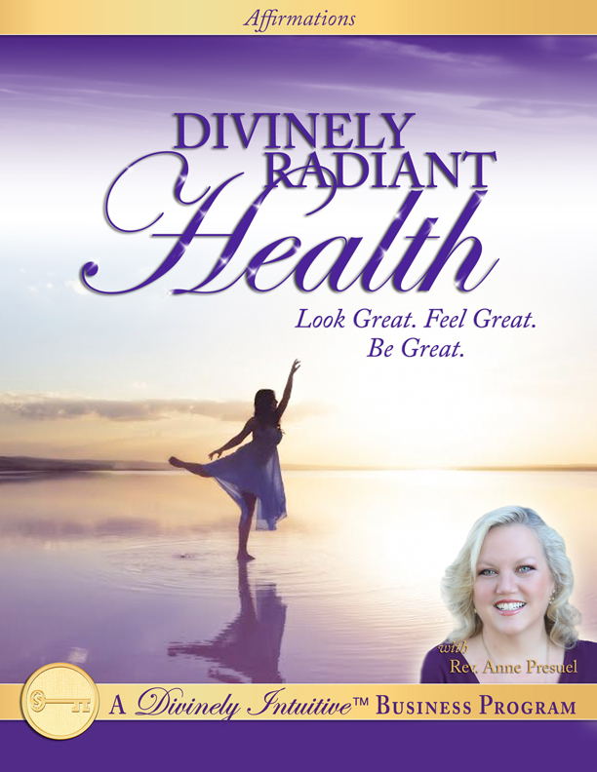
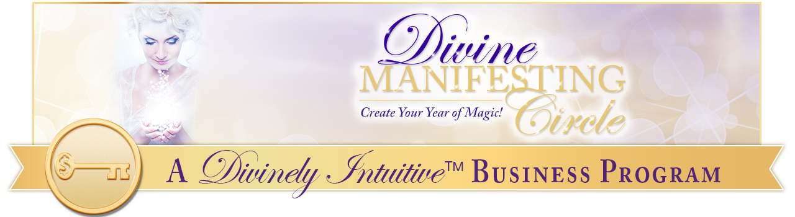
Divinely Radiant Health
Affirmations & EFT Points

Top of the Head: Every day, in every way, I am growing more and more healthy, beautiful and radiant.

Between the Eyes: My body is graced with fluidity and flexibility.

Side of the Eyes: I love to exercise and to move my body.

Under the Eyes: I love doing many different forms of exercise.

Under the Nose: I draw radiant health to me easily and effortlessly.

The Chin: God is the source of all my radiance and I am connected to this Source at all times.

The Collarbone: I am filled with the life and health of God in all areas of my life.

Under the Arm: I am delighted with my body and my body is delighted with me!

The wrist: I ask and I allow my body to maintain perfect health.

The Karate Chop: I have all the energy I need and I can create all the energy that I want!

Top of the Head: I am radiant with the light of God flowing through me.

Between the Eyes: I am interacting with life joyously, healthfully, abundantly and peacefully.

Side of the Eyes: My body knows how to balance itself.

Under the Eyes: It knows how to be health itself.

Under the Nose: I trust my body to do what it needs to do to maintain perfect balance.

The Chin: I am so grateful for my beautiful body.

The Collarbone: I love eating foods that support my body’s perfect health.

Under the Arm: I love to stretch my body.

The wrist: I love to feel my body.

The Karate Chop: I love to be in my body.

Top of the Head: Wondrous health comes easily to me.

Between the Eyes: Radiant, vibrant health is normal for me.

Side of the Eyes: Creating radiant health is effortless for me because I am always thinking thoughts of health.

Under the Eyes: I love being healthy!

Under the Nose: I am grounded and centered in my body.

The Chin: Great health is easy and comfortable for me.

The Collarbone: Thank You, God, for a healthy, happy body!

Under the Arm: Radiant health is here in my life now.

The wrist: A healthy body is my birthright.

The Karate Chop: Radiance is my natural state.

Top of the Head: I receive all of God’s good for my body and for my health.

Between the Eyes: I am perfect, whole and complete, just the way I am.

Side of the Eyes: I breathe easily and deeply.

Under the Eyes: I allow light to enter into my body on my breath.

Under the Nose: I am flourishing with each and every breath I take!

The Chin: My very breath draws life and health into my body!

The Collarbone: I am balanced in all ways.

Under the Arm: My energy flows beautifully and perfectly.

The wrist: I know that my connection to Spirit is always guiding me in everything I do.

The Karate Chop: This guidance brings me much delight and pleasure as I create my heaven on earth.

Top of the Head: I joyously feed my body good foods and clean water.

Between the Eyes: I delightfully feed my spirit good thoughts and blissful laughter.

Side of the Eyes: I radiantly feed my mind happy dreams and visions.

Under the Eyes: I use my God-given abilities to do this easily and consistently.

Under the Nose: I am an open channel for God’s perfect health and vitality to come through me now.

The Chin: I am pulsing with the rhythm of life itself!

The Collarbone: I create great health and I experience steady supply of sun-drenched energy in my life, here and now.

Under the Arm: I feel wonderful for I am filled with God’s great energy!

The wrist: I am excellent health in expression.

The Karate Chop: My life is a monument to God’s magnificent perfection!

Top of the Head: I am so grateful for my beautiful, wholesome, perfect body.

Between the Eyes: I love how my body knows what to do.

Side of the Eyes: My body is strong and vibrant, and it is filled with life and light!

Under the Eyes: I love being strong, fit and agile in my life!

Under the Nose: I love being alive with life!

The Chin: I love having abundant energy!

The Collarbone: Everywhere I look, I see radiant people.

Under the Arm: I hear only words of life spoken.

The wrist: I feel only perfection in my life.

The Karate Chop: I know that I am perfect health in perfect expression.

Top of the Head: The words of my mouth speak only love, joy, health and peace.

Between the Eyes: The thoughts of my mind think only thoughts of love, joy, health and peace.

Side of the Eyes: The perceptions I have of everything in my life is through the perception of love, joy, health and peace.

Under the Eyes: I choose to go to the stillness of my being to find the truth that lies within.

Under the Nose: I hear that still, small voice within, and I pay attention to its wisdom.

The Chin: I allow the light of God to flow through me.

The Collarbone: I allow myself to experience the lightness and the health of God.

Under the Arm: I love experiencing the life and health of God for it fills me with joy, energy and vitality.

The Wrist: I am willing and I am able to be happy and healthy.

The Karate Chop: I know how to be healthy, and I love being healthy! I choose being happy and healthy. Thank You, God. Thank You, God. Thank You, God!

xoxoxo,

Anne

Rev. Anne Presuel
Your 6th Sense Guide to a 6-Figure Business
www.DivinelyIntuitiveBusiness.com

