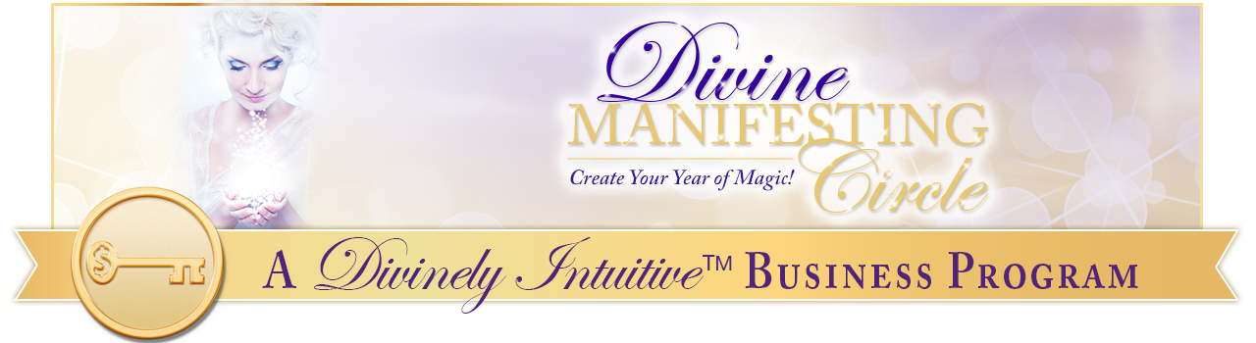
Ideal Body
Affirmations

I am clear about my vision for my life and for my sacred body.

In this clarity, I discover a freedom of being that until now I had only imagined.

My clarity brings focus and determination into my life.

I am clear about my life, my health, my relationships with others and about my next steps in bringing these understandings into being.

My body is in perfect proportion with curves and muscles in all the right places.

My stomach is getting flatter and flatter each and every day.

My butt is firm, curved and shapely.

My legs are strong, muscular and beautifully shaped.

My arms are firm, strong and beautifully shaped.

My body is firm, strong and beautifully shaped.

My skin is elastic and it reshapes itself beautifully as my body attains and maintains its ideal body size and weight.

My skin is smooth and unlined.

My skin cells regenerate themselves into more and more youthful cells as they allow the light and love of God to fill and sustain them.

I am a beautiful and magnetic being in all ways.

A healthy body weight is my birthright.

A toned body shape is my birthright.

A happy body size is my birthright.

Radiance is my birthright.

Strength is my birthright.

Beauty is my birthright.

Serenity is my birthright.

Conscious understanding is my birthright.

Happiness is my birthright.

Bliss is my birthright.

Wonder is my birthright.

I claim my birthright here and now.

Thank you, God.

It is easy for me to focus upon only that which I want because I have clarity of vision of all areas of my life.

I attract everything into my life with effortlessness and ease.

I attract my ideal body weight with effortlessness and ease.

I attract my ideal body size with effortlessness and ease.

I attract my ideal body shape with effortlessness and ease.

I attract people who support me in being at my ideal body weight with effortlessness and ease.

I attract the foods that support me being at my ideal body weight with effortlessness and ease.

I attract the exercises that support me being at my ideal weight with effortlessness and ease.

I attract everything I desire into my life with effortlessness and ease.
Thank you, Spirit.

I now draw into my life others who are also offering joyous, balance, vibrant thoughts of health.

We love to create together perfect health, perfect joy and perfect strength.

Creating my ideal body weight is effortless for me because I’m always thinking thoughts of health, joy peace and love.

These thoughts support me in loving my body and allowing it to attain its own perfect balance.

I have wonderful support of health-care practitioners if I need them or want them.
And they know how best to help my body attain and maintain its perfect weight.

Thank you, God.

I am consistently and easily contented and satisfied with my life and with those who share my life.

And I am so grateful for my beautiful healthy body.

Thank you, God.

I am always guided by Spirit.

I am always supported by Spirit.

I am always provided for by Spirit in all ways always.

Spirit speaks to me in many different ways and I am open and receptive to each and every one of them.

I hear what Spirit has to say.

I follow what Spirit has to say.

Spirit now richly provides all I could ever want in my life.

Thank you, God.

I love to get on a scale and see my ideal weight be.

I love being my ideal weight.

I love feeling my ideal weight.

I love shopping for clothes in smaller perfectly fitting sizes.

I love to be able to buy clothes in smaller perfectly fitting sizes.

I love wearing clothes in smaller perfectly fitting sizes.

I love wearing clothes that fit beautifully on my body.

I love to see my body slim, strong, toned and beautiful.

I love to feel my body slim, strong, toned and beautiful.

I love being slim, strong, toned and beautiful.

I love knowing I am slim, strong, toned and beautiful.

I love knowing I can eat whatever I want and that I can stop whenever I’ve had enough.

I love trusting my body to tell me when it had enough.

I love knowing I can be around others who are eating delicious foods and I love knowing I will not be tempted to eat any because I truly don’t want any.

I love knowing I can trust myself to know whether I want some food.

I love knowing I can trust my body to let me know whether it wants some food.

I love being powerful, strong and radiant.

I am fully open and receptive to the magic and the energies of the Universe helping me with every step of creating my ideal body, my ideal body size, my ideal body shape and my ideal body weight.

I know that I am supported by the magic and the unseen energies of the Universe in creating just this.

I am strong and I am flexible and I am sure of myself.

I am grounded and centered in my body.

I know the difference between being grounded and ungrounded in my body.

And I always make sure that I am grounded for this supports me in being present in each and every moment of everyday.

Being grounded supports me in being open to new ideas about my health, about my wealth and about my life.

Being grounded supports me in putting these new ideas into implementation for I am able to move forward with them more easily when I’m grounded in my body.

Being my ideal body size and weight is easy and comfortable for me.

Thank you, God, for a healthy, happy body.

I draw radiant health and a delicious, delightful supply of sun-drenched energy to me easily.

I am balanced in all ways. My energy flows beautifully and perfectly.

This balance assists me in attaining and maintaining my ideal body size, shape and weight.

I am happy. I feel Spirit’s delight.

I am cheerful. I laugh with Spirit’s humor.

I am healthy. I experience Spirit’s balance in my life.

I am wealthy. I know Spirit’s abundance in my life.

I am perceptive. I utilize Spirit’s wisdom in my life.

I am peaceful. I feel Spirit’s serenity in my life.

I am focused. I embrace Spirit’s clarity in my life.

I am calm. I experience Spirit’s quiet in my life.

I am harmonious. I welcome Spirit’s balance in my life.

I am congruent with each of these characteristics and I allow them to be in perfect expression in my life here and now.

I am a powerful radiant magnet for everything good. I now receive all of God’s good for my body and my health.

If something could go right for me today, it will, because I attract only the best in my life.

I believe this and I trust it with every bit of my being.

I breathe deeply and easily and as I do so, I allow light to enter into my body on my breath.

I am flourishing with each and every breath I take.

My very breath draws light and health, peace and vitality into my body.
I breathe easily and deeply.

My breath offers my body sacred life, sacred light and sacred wholeness.

Thank you, God.

It is safe for me to be at my ideal body weight for I draw into my life only those who have my highest good in their hearts.

It is safe for me to be beautiful for I draw into my life only those who have my highest good in their hearts.

It is safe for me to be incredible for I draw into my life only those who have my highest good in their hearts.

It is safe for me to be powerful for I draw into my life only those who have my highest good in their hearts.

It is safe for me to be happy for I draw into my life only those who have my highest good in their hearts.

It is safe for me to be brilliant for I draw into my life only those who have my highest good in their hearts.

It is safe for me to be delightful for I draw into my life only those who have my highest good in their hearts.

It is safe for me to be creative for I draw into my life only those who have my highest good in their hearts.

It is safe for me to be spiritual for I draw into my life only those who have my highest good in their hearts.

I am always safe for I walk with Spirit at each moment of everyday.

I joyously feed my body good foods and clean water.

I delightfully feed my mind good thoughts and blissful laughter.

I radiantly feed my Spirit happy dreams and visions.

I do these consistently and easily for I know it supports me in attaining and maintaining my ideal body size, shape and weight.

There is great love everywhere I look.

There is wondrous beauty everywhere I look.

The world is filled with rich colors and I see them everywhere I look.

There is great magnificence everywhere I look.

When I look at my body, I see great love.

When I look at my body, I see wondrous beauty.

When I look at my body, I see great magnificence.

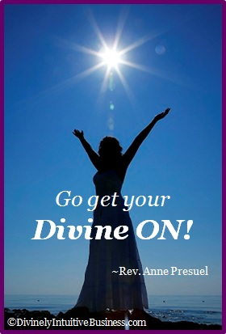
My mind and my life is a reflection of all of these and so much more for I am perfect, whole and complete just the way I am.

xoxoxo,

Anne

Rev. Anne Presuel
Your 6th Sense Guide to a 6-Figure Business
DivinelyIntuitiveBusiness.com

