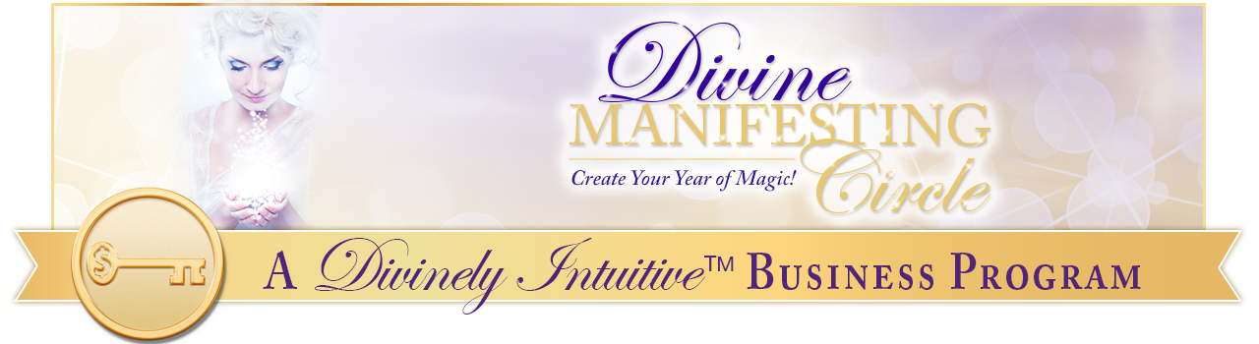Successful Sacred Sales Conversations
150 Affirmations to Make You LOVE Sales!

Today, I choose to make sales calls.

Today, I choose to have strategy sessions.

Today, I choose to be an advocate for not only my business, but also for my prospective client.

I know that it is through having sales conversations that this is done.

I LOVE sales!

When I am on a call, I am very quick to know whether the prospective client is a good fit for me – or not.

And if I become aware that they are not a good fit, I easily refer them elsewhere or

I end the conversation graciously.

I am very clear who my ideal clients are and I choose to fill my business only with ideal clients.

I love picking up the phone to call my leads and I always have plenty of leads to call.

When I do this, the people who receive my calls are happy to hear from me. They enjoy our call.

We connect easily.

I know that when I do this, I am offering someone an incredible opportunity to transform their life and their business.

Because I am very clear that sales is transformation!

Sales is the sacred vehicle through which my clients say yes to themselves!

Sales are the sacred vehicle through which my clients say yes to the Divine.

Sales are the sacred vehicle through which my clients say yes to their lives, their dreams … their visions.

These dreams, these visions, have been given to them by the Divine and when we talk and they say yes to themselves, they say yes to the Divine.

It is through the sales conversation that my prospective client moves into a whole new place of being.

Each call allows us to move to a new place of understanding and awareness in both our lives.

When I am fully present, our conversation becomes deep, and rich and intimate.

Sales conversations are the connecting tool through which we do this.

Sales conversations are fun!

Sales conversations are powerful!

Sales conversations are amazing!

I LOVE sales conversations!

I know that when I connect with my potential client, I hold for them their dream.

I hold for them their vision.

I hold for them their hopes.

I hold for them the space of their transformation.

I hold their heart.

And I hold it with all the sacredness that it deserves.

I know that I have what they need in that perfect moment in time.

I know that I can help them.

I know they need what it is I offer.

And I know that it is my job to help them get clear so they can take their next step.

I do this easily and effortlessly.

Each of my sales conversations or strategy sessions offer me the opportunity to deepen my listening skills.

I LOVE hearing what my prospective clients have to say, what they are working through and discovering how I can help them.

I am clear that listening to them and being present is one of the greatest gifts I can give.

And I know that the strategy session or sales conversation is not about me; rather, it is all about my prospective client.

In each conversation, I am willing to go deeper and deeper into the truth of what blocks someone from having what it is they want, even if they are afraid.

Even if they are in pain.

Even if they want to run away because they are scared.

Even if.

It doesn’t matter what their reaction is. I know that when I ask bold questions, it allows them to uncover their blocks and fears.

I know that offering them my bold questions, my listening and my presence is one
of the greatest gifts I could give.

For it is in this experience that their life – and their business – is transformed.

Because of this, I am willing to be VERY bold in my strategy sessions.

I am willing to let go of my fears of rejection, of loss of looking stupid; and I am willing to be present with and for them.

When I am bold, when I am fully present, when I am willing to let go of my fear, it is then that my sales conversations become sacred.

I know how to do this and I am willing to do this.

I am willing to do it frequently.

I am willing to have sacred sales conversations, frequently, for my business, for myself and for the transformation of my business and myself.

I am willing to have sacred sales conversations with my prospective client for their transformation.

And when we have had a sacred sales conversation, it is truly a success!

And successful sales conversations are easy for me to have!

I absolutely LOVE having sacred sales conversations!

I LOVE picking up the phone and calling people!

I LOVE connecting with them, deeply and powerfully!

Each prospective client and I connect deeply, because they are willing to trust me and they are committed to their own transformation.

It is easy and fun to do this!

ALL of my sales calls are focused and clear.

All of my sales calls are rich and intimate.

All of my sales calls are indeed sacred.

I LOVE having sales calls.

I LOVE MAKING sales calls!

I LOVE connecting with people!

I am confident in my sales calls.

I am bold in ALL of my sales calls.

I am willing to listen to my prospective client in ALL of my sales calls.

I am willing to be present in ALL of my sales calls.

I am willing to experience the sacredness of ALL of my sales calls.

I always come from a place of service – in all of my calls.

It is my deepest intention that I support my prospective client move forward in each and every call.

My strategy sessions or sales calls are always focused on assisting others in moving forward in their business and in their lives.

During my calls, I always trust my intuition.

I always trust my inner guidance because I am deeply connected to the Divine.

Because of this, I am always guided to the right and perfect thing to say
during my calls.

I know I am always guided to the perfect thing to say in each moment of the call.

And I know exactly what to say in my calls.

I am not afraid to be bold.

I am not afraid of rejection.

I confidently offer what it is I have to my prospective clients.

I know that this confidence helps my prospective clients feel confident in me and that this confidence transforms our calls.

Because of this, many prospective clients become actual clients, as they willingly and readily step into their transformation and possibility.

I confidently offer strategy sessions to prospective clients.

All of my strategy sessions are unique and interesting.

All of my strategy sessions are easy to do, and easy to have.

I love having strategy sessions!

I LOVE having sales calls!

I make lots of sales calls because there are lots of people who want to work with me.

My reputation precedes me and that is a good thing.

When we speak, my prospective clients become present to how much they want to work with me.

They easily determine that it is the right thing to do.

They easily say yes!

They easily sign contracts.

They easily pay for my services.

What an incredible gift I give to others!

What an incredible transformation they make because of this gift! Because of this courage. Because of my boldness. And because of my willingness.

I have a waiting list of potential clients ready and anxious to have sales conversations with me!

And my client list is Full!

My prospects come to me easily and effortlessly.

I find perfect potential clients everywhere I go, online and off… at every event I give or attend, on every teleseminar I offer, in every forum within which I participate.

Everywhere I go I find new potential clients. Potential clients who are interested in talking with me about working with me.

My prospects find me through my website, through social media and through myriad online and offline marketing strategies.

I easily and effortlessly draw new clients to me wherever I go.

They want to talk with me about working with me and they are not afraid to ask.
Everywhere I go, I find new clients and prospective clients.

It is so easy to close sales because there are lots of people who want to work with me!

I know how to ask for the money.

I know how to ask for the work.

I know how to ask my potential clients to step into their possibility with me.

And I am not afraid to do so.

I know how to bring my sales conversations to a very satisfactory close, easily and effortlessly.

Today, I close in my sales calls.

Today, I fill my business with perfect, ideal clients.

And I have great fun doing it!

I choose to be a space of possibility for my potential client.

I choose to be a space of love.

I choose to be a space of possibility.

I choose to be a reflection of the Divine.

I know that as I am clear, I offer my prospective client the opportunity to become clear.

Today, I allow the truth of the Divine to flow through me.

Today, I allow the wholeness of the Divine to flow through me.

Today, I allow the peace of the Divine to flow through me.

Today, I allow the love of the Divine to flow through me.

And as I do this, I open up the space of transformation to be present.

Today, I am honored to be this Divine channel of truth, of Divine wholeness, of Divine peace, of Divine love, of Divine potential for my prospective client.
There is no higher service.

Today, I gift my prospects with my love, with my truth and with my clarity.

Today, I gift my prospects with my sacred offering of service.

Today, I gift my prospects with the experience of sacred sales.

Today I am of complete service to the Divine.

Today, I AM of service.
Today, I AM transformation

Today I am sacred sales.

Today, I have successful sacred sales conversations.

Today, I AM one with the Divine in all that I say, all that I do and in all that I am, in all ways, always.

And so it is. Thank you God, Thank you God, Thank you God.

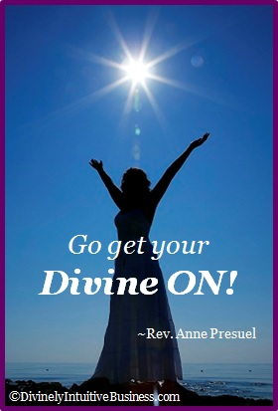

xoxoxo,

Anne

Rev. Anne Presuel
Your 6th Sense Guide to a 6-Figure Business
www.DivinelyIntuitiveBusiness.com

