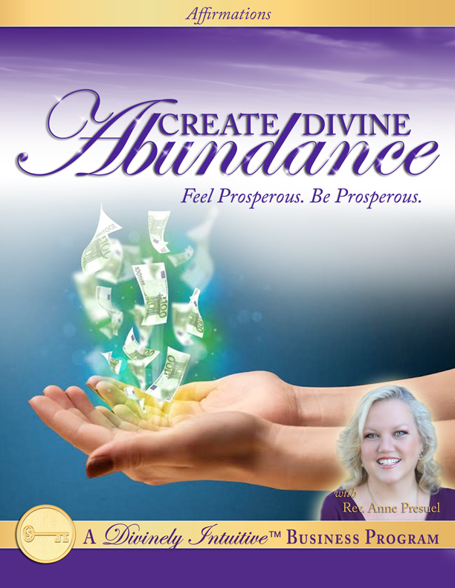
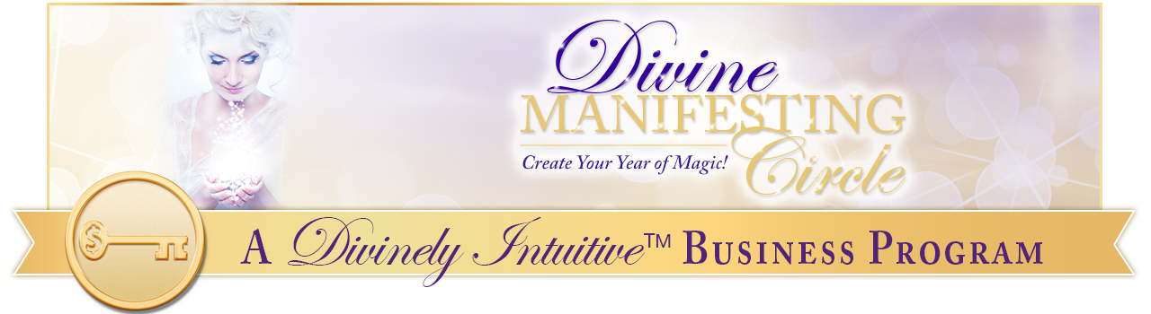
Create Divine Abundance
Affirmations with EFT Points

Top of the Head: Every day, in every way, I am growing more and more prosperous!

Between the Eyes: I draw abundant wealth to me easily and effortlessly.

Side of the Eyes: I am happy, I am healthy, I am wealthy and I am wise.

Under the Eyes: I have all the money I could ever need or want.

Under the Nose: I am wealthy, abundant and prosperous!

The Chin: Money and success come easily to me.

The Collarbone: I draw money to me easily and effortlessly.

Under the Arm: God is the source of all my abundance and I am connected to this source at all times.

The Wrist: I am radiant with the light of God flowing through me.

The Karate Chop: I am filled with the sumptuousness of God in all areas of my life.

Top of the Head: I am interacting with life joyously, abundantly, creatively and peacefully.

Between the Eyes: I am a radiant, magnetic being in all ways.

Side of the Eyes: I attract everything I desire into my life with effortlessness and ease.

Under the Eyes: Magnificent abundance is my birthright, and it is my natural state.

Under the Nose: Spirit now richly provides all I could ever want in my life. Thank You, God!

The Chin: I am an open channel for God’s incredible prosperity to come to me now.

The Collarbone: Superb wealth is here in my life now. I have more money than I know what to do with!

Under the Arm: I am fully supported, deeply loved, and magnificently powerful!

The Wrist: Money flows into my life wherever I am, whenever I need it, and at whatever time.

The Karate Chop: If something can go right, it will. I trust this with every bit of my being.

Top of the Head: Only good things come into my life now. I have nothing to fear.

Between the Eyes: Success is easy and comfortable for me.

Side of the Eyes: I have everything within me to become rich beyond my wildest dreams.

Under the Eyes: I have all the prosperity I could ever need or want.

Under the Nose: God is the source of all my abundance, and I am connected to this source at all times.

The Chin: I focus my attention and I focus my energy on having exactly what I want manifested in my life.

The Collarbone: I am discovering my own amazing, intelligent, vibrant, abundant, creative, sacred self, and I am loving what I am discovering!

Under the Arm: I am bursting with energy, light and strength!

The Wrist: I am bursting with power, abundance and affluence!

The Karate Chop: I am all I can be at every moment of every day.

Top of Head: I allow myself to experience the lightness of God.

Between the Eyes: I am always supported by God.

Side of the Eyes: I am always guided by God.

Under the Eyes: I am always provided for by God.

Under the Nose: I am willing and I am able to be successful and happy.

Chin: Incredible financial success is here in my life now!

The Collarbone: Money now flows easily to me.

Under the Arm: I have all the money, all the love, all the joy, all the peace that I could ever need or want.

The Wrist: I am bursting with grace, with beauty, with power. Thank You, God.

Karate Chop: I am radiant with the light of God flowing through me.

Top of the Head: I know there is an infinitively abundant supply of wealth in this Universe and I claim my supply now.

Between the Eyes: Money flows into my life wherever I am, whenever I need it, and at whatever time.

Side of the Eyes: I am balanced in all ways. My energy and my money flows beautifully and perfectly.

Under the Eyes: I open my eyes to see through God’s eyes.

Under the Nose: I open my heart to feel through God’s heart.

The Chin: I open my ears to hear God’s ideas.

Collarbone: I open my mouth to speak God’s words.

Under the Arm: I touch with God’s touch, and I feel God’s touch in the touch of others.

The Wrist: I am always provided for by Spirit.

Karate Chop: Spirit speaks to me in many different ways.

Top of the Head: I am open and receptive to each and every one of these ways.

Between the Eyes: I love to do what I am guided to do.

Side of the Eyes: I trust my guidance and I follow it implicitly!

Under the Eyes: I know that unseen, loving energies are always supporting me in every endeavor.

Under the Nose: Creating effortless abundance is easy for me because I am always thinking thoughts of great wealth.

The Chin: It is easy for me to focus only upon that which I want because I have clarity of vision in all areas of my life.

The Collarbone: I am a powerful, compelling magnet for everything good!

Under the Arm: If something can go right for me today, it will!

The Wrist: I am bursting with energy, with love, with light and with abundance!

The Karate Chop: I am all I can be at every moment of every day, and it is pretty magnificent. Thank you, God!

And so it is.

xoxoxo,

Anne

Rev. Anne Presuel
Your 6th Sense Guide to a 6-Figure Business
www.DivinelyIntuitiveBusiness.com

