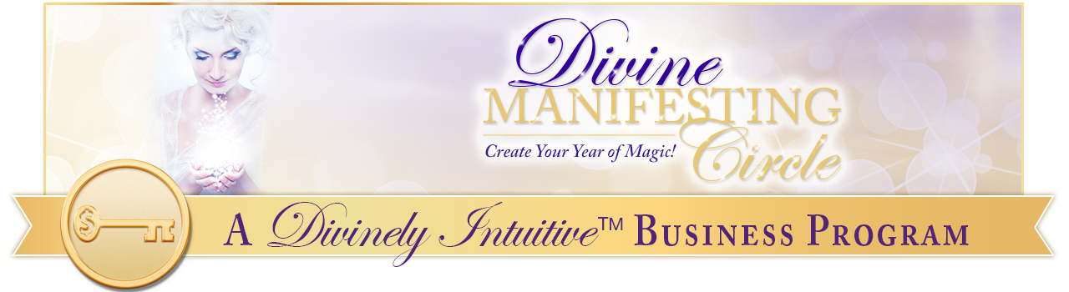
Your Divine Brand
Affirmations

Many spiritual entrepreneurs that I know and work with feel challenged at times as they create their brands. They know that a brand is important, but aren’t really sure what is in a brand, or what makes a strong brand.

If this sounds familiar, then you are in the right place. These affirmations will help you access your own Divine brand – the one that represents you and your sacred work powerfully … one that inspires others to want to learn more about you and even to work with you.

In addition, they will help you:

- open yourself up to discover your Divine brand – its looks, its message, its colors, its style,
- open yourself to a new way of thinking about your work, your offers and your own value;
- open yourself to receiving the abundance of the Divine – in clients, in opportunities, in connections, and of course, money!

You will stand confidently in your connection with the Divine, knowing you are always provided for – in all ways, always.

Most of all, you will remember that your work – and your brand – is a beautiful and sacred expression of the Divine in this world, and that you are one who has come to share your gifts with others, and to bring light where there has been darkness.

Standing in this powerful Truth, you are very Divinely attractive!

How to use these affirmations:

- Listen to the mp3 recording that accompanies this report. Listen as you are:

- going to sleep,
- doing any sort of exercise that is calm (like yoga),
- receiving bodywork (i.e., massage, reflexology, craniosacral therapy, reiki, etc.),
- washing dishes or cooking dinner,
- driving errands,
- meditating,
- tapping,
- walking,
- working (play it in the background on your computer),
- and any other way you can think of.

- Say the affirmations out loud to yourself. Tap while you say them. The bold statements are power statements. They have more powerful energy behind them. Say them out loud with emphasis!

- Create your own recording of them in your own voice. Change words to fit your particular situation. Then listen to your own recording. Your subconscious will believe you and take action faster than if you just read the affirmations or listen to them in my voice. (It’s more powerful because it always is listening to you in your voice.)

Ok, so here we go!

Today, I get quiet and connect with my perfect brand.

I am open and willing to see it.

I know what it wants me to see,

I am willing to hear what it wants to say.

I can feel my brand sharing itself with me.

I know what it is trying to say.

I can hear it calling me.

I can see it beckoning.

I can feel it.

I know it is there.

I am open to receiving it.

I trust what I receive.

I know that the brand I am connecting with is perfect for me, for my business, and for my work.

I am guided to my perfect brand.

I know that the perfect name for my brand is calling me.

I am open to receiving it.

I hear it easily.

I see its beauty.

I know it deep in my being.

I feel its presence in my soul.

I know that the perfect tagline is available to me now.

My tagline is the ideal reflection of my wonderful work.

My tagline represents me to the world in a beautiful, powerful way.

My tagline is a clear expression of the transformation my clients receive.

It is interesting and clear, because I am clear about my message to the world.

It is easy for me to fully create a powerful brand that fully represents my work.

My logo is clear and meaningful to me.

My logo is clear and meaningful to others.

My logo reveals itself with me easily.

It is beautiful and clear.

It is powerful and inspiring.

It is juicy and inviting.

I see it easily.

I know what it is saying.

I can feel its message.

And it wants me to share it with the world.

Today, I receive the vision for my perfect brand in a perfect way.

My colors and fonts are a perfect reflection of my brand.

They reflect its message beautifully.

People know who I am and what work I do just by seeing my brand.

My brand is clear and concise.

My brand it inspiring and invitational.

My brand is something I am very proud of.

My brand is a clear reflection of me and my sacred work.

It draws to me my perfect, ideal clients.

Creating my brand is fun and easy!

I am clear about all the pieces which make up my brand.

It is easy for me to create each piece, because I allow each one of them to reveal itself to me.

My brand is clear, juicy and fun!

It is an accurate representation of the sacred work I do with my clients.

I am clear that I am my brand.

I know that my brand is a reflection of my reputation.

I keep my brand clean and clear.

I keep my work with clients and others, because I know that doing so maintains my reputation.

Doing so maintains the integrity of my name.

Doing so maintains the integrity of my brand.

I LOVE my brand!

I LOVE my message!

I LOVE my work!

I am filled with gratitude that all of this is true, right here and right now.

Thank You, God! Thank you, Spirit!

Thank you, Most Divine, Holy One!

And it is so. And so it shall be. Now and forever more.
Amen.

xoxoxo,

Anne

Rev. Anne Presuel
Your 6th Sense Guide to a 6-Figure Business
DivinelyIntuitiveBusiness.com

