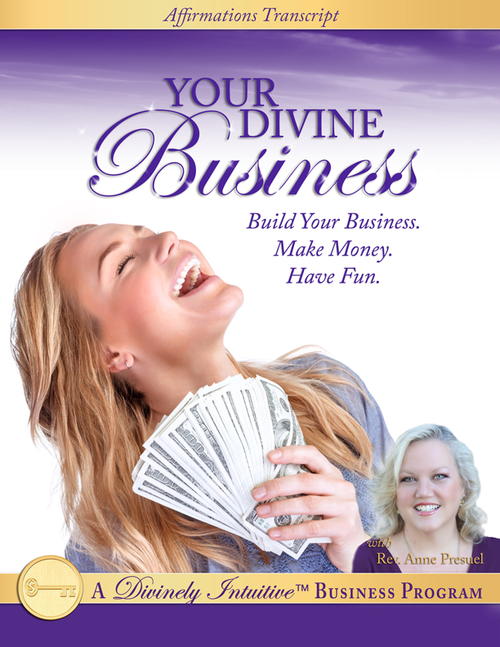
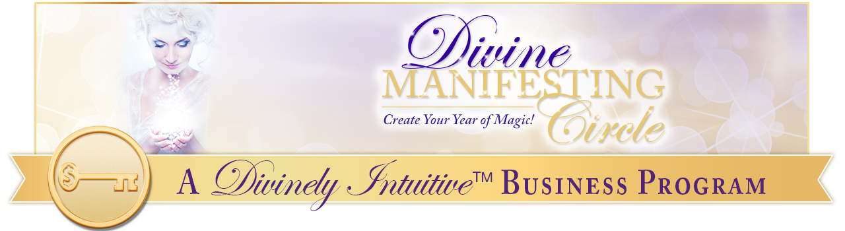
Your Divine Business
Affirmations

Many spiritual entrepreneurs that I know and work with feel challenged at times as they build their businesses. They know they feel called to do the sacred work they are doing, yet they wonder if maybe they’ve missed something along the way.

For some reason, the business just isn’t taking off the way they thought it would. Surely they weren’t wrong – they were guided to do the work. But why isn’t it more successful? Why is it so hard to find clients? Why aren’t they making more money? Why do they feel so overwhelmed?

They wonder what’s wrong with them and whether they can stick it out to actually build their business!

If this sounds familiar, then you are in the right place. These affirmations will help you remember the Truth of why you are doing what you are doing: that you were called to do this work. In addition, they will help you stand strong when you feel like giving up, they will help you open yourself to receiving the abundance of the Divine – in clients, in opportunities, in connections, etc. - and they will help you feel the peace that passes all understanding.

You will stand confidently in your connection with the Divine, knowing you are always provided for – in all ways, always.

Most of all, you will remember that your work is a beautiful and sacred expression of the Divine in this world, and that you are one who has come to share your gifts with others, and to bring light where there has been darkness.

Standing in this powerful Truth, you are very Divinely attractive!

How to use these affirmations:

- Listen to the mp3 recording that accompanies this report. Listen as you are:

- going to sleep,
- doing any sort of exercise that is calm (like yoga),
- receiving bodywork (i.e., massage, reflexology, craniosacral therapy, reiki, etc.),
- washing dishes or cooking dinner,
- driving errands,
- meditating,
- tapping,
- walking,
- working (play it in the background on your computer),
- and any other way you can think of.

- Say the affirmations out loud to yourself. Tap while you say them. The bold statements are power statements. They have more powerful energy behind them. Say them out loud with emphasis!

- Create your own recording of them in your own voice. Change words to fit your particular situation. Then listen to your own recording. Your subconscious will believe you and take action faster than if you just read the affirmations or listen to them in my voice. (It’s more powerful because it always is listening to you in your voice.)

Ok, so here we go!

I LOVE being in business!

And I love my business!

I know that I am bringing my gifts to the world in the unique and wonderful way that only I can do.

I am deeply connected to my work.

I am deeply committed to bringing my work to the world around me.

I know that it is through my own transformation that the world around me is transformed.

I know that I have been given gifts from the Divine … so that I can express them in many ways.

I know that I came to share these gifts.

I love sharing my gifts!

I love seeing others’ lives transformed through my gifts.

And they are indeed transformed.

I am deeply grateful for my gifts.

Today, right now, I take a moment and I say “Thank You” to the Divine, to Spirit for my incredible gifts.

I know that when I do this, I allow my gifts to expand powerfully and quickly.

I am willing to bring my gifts to the world in a powerful, abundant way.

The most effective way that I know to do this is through my business.

I love building my business!

It is so easy for me!

I always know what to do … and I am always guided as to how to do what I am guided to do.

I have all the support I need to build my business.

I have all the guidance I need to build my business.

I have all the help I need to build my business.

I have all the faith I need to build my business.

I have all the money I need to build my business.
I easily create whatever it is I need (or want) as I build my business.

When I want a great team, I easily create the opportunity (and the money) for great people to work with me.

When I want a project done, I easily create the systems and the support to complete that project.

It is easy for me to make deals and manage multiple projects.
When I want money to expand my business (and live my life abundantly), I easily and quickly create the money I desire.

My Divine and perfect business brings me more and more joy and freedom as it grows and grows.

Building a business is so easy – and fun!

Making an abundant living is so easy and fun!

Every day, in every way, I am growing in my ability to build my business, to make
great connections with other entrepreneurs and with my tribe and to share my message in a powerful, effective way.

I know that being an entrepreneur allows me a freedom of being that is unavailable to me anywhere else… and I totally embrace this freedom!

I embrace the growth that comes with this freedom.

I embrace the experiences that come with this growth!

And I embrace the wealth that arises from stepping into my full potential.

Today, I choose to receive.

Today, I choose to receive the wealth that is my birthright.

I choose to receive the freedom that is my birthright.

I choose to receive the expansion of consciousness that is my birthright.

Today, I welcome growth!

Today, I welcome expansion!

Today, I am willing to do what makes me uncomfortable so that I can have the growth, the expansion, and the wealth that are my birthright.

I know that being uncomfortable is only a temporary place.

And that today’s discomfort is tomorrow’s comfort.

Today, I am willing to step outside of my box of known ideas, people and methods of action so that I can experience the growth and expansion and wealth that are my birthright.

Today, I welcome this new place of being.

Today, I choose this new place of being.

I know that it is my willingness to move through my blocks, through my fears and through my limiting beliefs that allows me to step into this new place.

It allows me to become unrecognizable.

Today, I choose to be unrecognizable!

Today, I choose to be powerful!

Today, I choose to be bold!

Today, I choose to be willing!

Today, I choose to know I am capable!

Today, I believe in myself.

I believe in my gifts!

And I believe in the Divine.

I know I would not have been given the gifts that I have been given had I not also been given the way to share them abundantly with the world.

In all ways, I am guided by the Divine as I build my business.

I trust myself.

I trust the Divine… to guide me, to show me, to open the ways before me, to bring me the perfect people at the perfect time, to bring me the perfect connections and my perfect clients.

I trust my connection to the Divine.

I trust and I know that I am guided to each and every challenge.

I trust and I know that I am guided in each and every challenge, each and every situation, and to each and every solution and resolution.

I know this to be true deep within my being.

I believe in myself and I believe in my business.

I love bringing my work into the world in a powerful way.

I love being powerful in my work.

And today, I stand in my power as a business person.

I am a very smart business person!

I am strong, I am smart and I am powerful!

I am very clear about the direction I am going in my work and in my life.

And I am excited about the direction I am going in my work and in my life.

I am guided by the Divine every step of the way.

I walk each step with confidence and faith.

I am fearless as I build my business.

I know I am influential in my work and I love holding that space of influence.

I love being connected with others in my community.

I love being a leader in my field and industry and I know that it is safe for me to be a leader.

People respect me and they respect my work.

People want to work with me!

And they are so excited to work with me!

Clients find me wherever I go.

And I love working with them.

When they work with me, their lives are transformed.

I have many different ways that people can work with me.

I make it easy for them to do so.

I have a full client list, and a waiting list of people who want to work with me!

Clients find me easily, and they decide to work with me because they know their lives will be transformed.

Because of this, my business is expanding exponentially.

And I am loving every moment of it!

I am profoundly grateful that this is so.

And I say “Thank You, God, Thank You, God, Thank You, God!”

And so it is…in all ways, always, now and forever more. Amen.

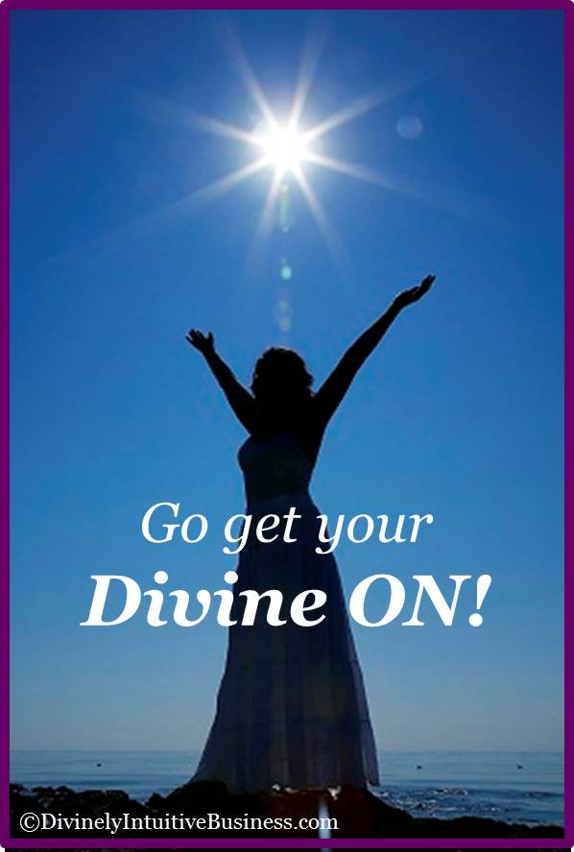
Create a fabulous day!

xoxoxo,

Anne

Rev. Anne Presuel
Your 6th Sense Guide to a 6-Figure Business
www.DivinelyIntuitiveBusiness.com

