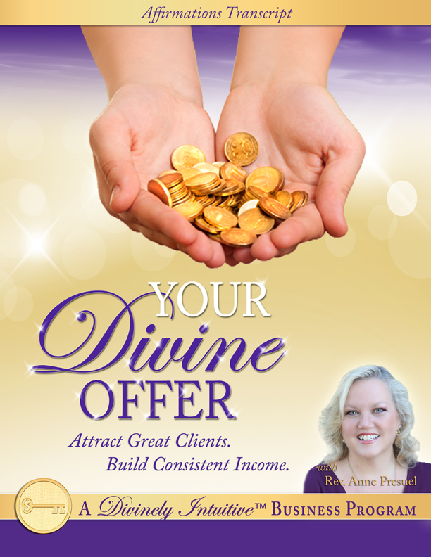

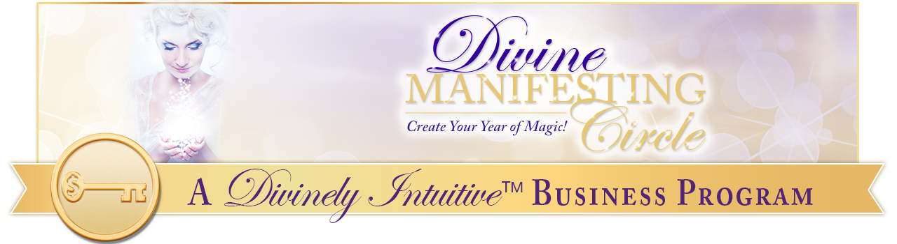
Your Divine Offer
Affirmations

Many spiritual entrepreneurs that I know and work with feel challenged at times as they create their offers. They know they feel called to do the sacred work they are doing, yet they wonder if maybe they’ve missed something along the way.

For some reason, the business just isn’t taking off the way they thought it would. Surely they weren’t wrong – they were guided to do the work. But why isn’t it more successful? Why is it so hard to get clients? Why aren’t they making more money? Why do they feel so overwhelmed?

They wonder what’s wrong with them and whether they can stick it out to actually build their business!

If this sounds familiar, then you are in the right place. These affirmations will help you remember the Truth of why you are doing what you are doing:

You were called to do this work.

In addition, they will support you to:

- Create Divine offerings for your ideal clients,
- Stand in your power regarding your work, your offerings and your value;
- Receive the abundance of the Divine – in clients, in opportunities, in connections, and of course, money!

You will stand more confidently in your connection with the Divine, knowing you are always provided for – in all ways, always.

Most of all, you will remember that your work is a beautiful and sacred expression of the Divine in this world, and that you are one who has come to share your gifts with others, and to be the light.

Standing in this powerful Truth, you are very Divinely attractive!

How to use these affirmations:

- Listen to the mp3 recording that accompanies this report. Listen as you are:

- going to sleep,
- doing any sort of exercise that calms you (i.e., yoga),
- receiving bodywork (i.e., massage, reflexology, cranio-sacral therapy, acupuncture, reiki, etc.),
- washing dishes or cooking dinner,
- driving errands,
- meditating,
- tapping,
- walking,
- working (play it in the background on your computer), and
- any other way you can think of.

- Say the affirmations out loud to yourself. Tap while you say them. The bolded statements are power statements. They have more powerful energy behind them. Say them out loud with emphasis!
- Create a recording of them in your own voice. Change words to fit your way of thinking and speaking. As you listen to your own recording, your subconscious will believe you and take action faster than if you just read the affirmations or listen to them in my voice. (It’s more powerful because you are always listening to your own voice.)

Ok, so here we go!

Today, I confidently offer my services to the world.

It is easy to create my offer in a grounded, practical, yet Spirit-driven way for I am guided by the Divine as I create it.

I know that it is up to me to listen to the Divine – to listen to my intuitive connection to the Divine – as I create my offer so that it is the most powerful, beautiful gift I can give.

And so I get quiet.

I ask for the guidance.

And I know that it is provided, just as soon as I ask.

It is easy for me to listen.

It is easy for me to hear.

It is easy for me to know.

And it is easy for me to trust.

I trust what I receive in my deep connection with the Divine.

And I take action upon what I receive.

Easily.

Quickly.

I have the gift of discernment as I tune into my intuition.

And I use it.

With grace.

With confidence.

With love.

Today, I get quiet as I go within and listen to that still, small voice inside.

And as I get quiet, I trust what I receive.

I trust the inner guidance coming through to me in various ways.

I know I am guided perfectly by the Divine.

I know that what I offer is powerful and profound.

I know that what I offer is sacred and blessed.

I know that what I offer is transformative and valuable.

I know that the transformation I offer is cherished and desired by my clients.

I am confident in its value.

I am clear that when I make my offer, it inspires others to step into a whole new place of being.

My offer allows my prospective clients to make decisions based on faith and possibility rather than fear.

It allows them to see themselves in a whole new light.

It allows them to know themselves more deeply, more powerfully and more intimately than ever before.

When I make an offer, it gives my prospective clients the opportunity to grow in their faith in themselves…

In the Divine…

And it gives them the opportunity to grow in their understanding and their confidence in themselves and in their connection with the Divine.

When I give my offer, I receive the opportunity to grow in my own faith in myself and in my work.

This gives me the opportunity to grow in my confidence and understanding of myself, of my work and my understanding of my connection with the Divine.

Every time I offer my services to others, I grow in my confidence - and in my conviction - that my services are needed - and wanted - by my market.

I am clear that my people want my offer.

I am clear that my people are looking for my offer… right now, even as I speak.

I am clear that my people are hungry for what I have to offer them, and that I am being of service to them when I offer it to them.

I am clear that when I offer my services to the world, it says “Yes!” to me!

The world says yes in myriad ways: financial, connectedness with others, visibility of my work, and acceptance of my status as an expert.

Today, I say “Yes!” I share myself with the world.

Today, I say “Yes!” I share my sacred gifts with the world.

Today, I say “Yes!” I share my powerful gifts with the world.

Today, I say “Yes!” I share my sacred beingness with the world.

Today, I say “Yes!” I share my offer with the world.

And the world responds.

With grace.

With appreciation.

With enthusiasm.

With welcoming arms.

Today, I willingly share my offer with the world, and it says “Yes!” to that offer.

My offer is clear, well-organized and filled with goodies!

My offer is powerful, juicy and very desirable.

My offer is strong, marketable and creates great interest.

My offer provides a win-win for everyone involved.

And people find it easy to say “Yes!” to it!

And I find it easy to say “Yes!” to them.

Today, everywhere I go, I experience “Yes!”

I say “Yes!” to others.

My prospective clients say “Yes!” to me.

The world says “Yes!” to us all.

And the Divine says “Yes!” – in all ways, always.

Today, I am unafraid as I share my sacred self with those around me.

I willingly and openly share myself and my work powerfully.

It is safe for me to share myself this way.

It is safe for me to surrender myself to the Divine in this way for I know that when I do, I am provided for in all ways, always.

No harm can come to me with those I love as I do the work of the Divine in this world.

I AM the expression of Divine love in the world.

I AM the expression of Divine peace in the world.

I AM the expression of Divine wholeness in the world.

I AM the expression of Divine faith in the world.

I AM the expression of Divine trust in the world.

Today, I choose to be the expression of the Divine in my life in all ways.

I know that choosing to be the expression of the Divine in the world is powerful, beautiful and sacred.

Today, I choose to be this sacred expression to those around me.

I know that by doing this, I give others permission to do the same.

I know they see this expression of the Divine and they are inspired to live their truths in a more powerful way.

Today, I generously and graciously share myself and my gifts with the world.

And I am happy.

I am profoundly blessed as I bless others with my gifts.

My sacred gifts are accorded the respect and honor they deserve because I treat them with the respect and honor they deserve.

And the world responds in kind.

Today, I am the holy expression of the Divine through my gifts and through my offer.

Today, I recognize the transformation I provide to my clients.

I know that this transformation is the very thing that changes their lives.

I know that this transformation is something they will pay for.

I know that they will do anything to create it because it is what they ache for.

I know that this transformation is sacred, holy and blessed, and I treat it as such.

Today, I bless the world around me with my gifts of love, of beauty, and of authenticity.

Everything I do is touched with these gifts.

Every offer I make is guided by these ideals.

Every conversation, every marketing action and every intention I have or make is touched by these values.

Today, I offer myself to the world in a powerful, authentic way.

I know my offering has value.

I know my offering is treasured by those who can accept it.

I know my offering is precious to those who desire it.

And I know that the transformation I provide is priceless to those who receive it.

Today, my offer stands up.

Powerfully.

Proudly.

Persuasively.

I know that those who say “Yes!” are saying “Yes!” to themselves.

They are saying “Yes!” to their own transformation.

They are saying “Yes!” to the Divine.

Today, I embrace my tribe.

Today, I embrace my people.

Today, I embrace my market.

I know that I provide them with a powerful offering, and I know that those who are ready for transformation will say “Yes!”

And so it is. In all ways. Always.

And so we say “Thank You, God,” “Thank You, God,” “Thank You God.”

And so it shall be. Now and forever more. Amen.

May you know the truth of these statements, deep inside your being.

And may you own them as your own Divine truth.

For you are blessed.

You are powerful.

You are perfect.

You are whole and you are holy.

And it is so.

xoxoxo,

Anne

Rev. Anne Presuel
Your 6th Sense Guide to a 6-Figure Business
DivinelyIntuitiveBusiness.com

