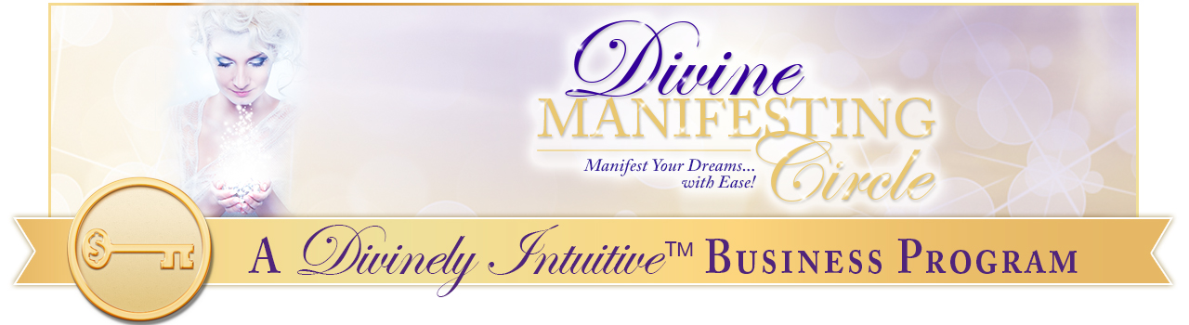
Visualization Script
Cleansing Your Body Energies

This is a recording for you to tap along with as you cleanse your body’s energies. Just put everything aside and get comfortable. Take a nice deep breath in, and release it. And now take another nice deep breath in, and release that.

Get present to your body. Get present to how it feels. Just get comfortable. Right now tell your body “Thank you” for all of the work that it does. Tell it “You are beautiful, you are magnificent, and I am grateful for everything that you do.”

Now tap along while I’m talking. Just start at the top of the head and move through the points as I talk. (Pause)

Take a deep breath in and get centered. (Pause)
I am so grateful for my body.

I am so grateful for my strong body.

I am so grateful for my beautiful body.

My body carries me everywhere I go.

It does such beautiful things for me.

And I trust it and it trusts me.

My body always tells me what it needs and I listen to it.
I listen to my body’s deep wisdom and I receive this information into my conscious awareness.

I trust my body. I love my body.

I love being in my body. It is safe for me to be in my body.

It is safe for me to be here. I am a being of light.

I receive light into my body now.

Now envision a beautiful bright light coming into your crown chakra – the top of your head, infusing your body with this beautiful light from God…

And envision a beautiful brilliant white light coming up through your feet chakras, up though your feet, up your legs, and meeting with the light coming in through your crown chakra … you are filled completely with this brilliant light.

Feel it fill your body and allow it to extend outward from your body, cleansing your aura, sending love and peace wherever it flows.

And know these truths:
I am light.

I am God’s light, the light of the Divine.

God’s light flows into me and through me, as me. I allow this light to flood my very being and it is expanding outward from me into my beautiful energy field.
It expands out around me, cleansing everything.

I allow it to expand as far as I desire.

I allow it to cleanse everything.

I notice how far out it is.

I allow this light energize me, to energize my aura and to expand it.

Take a nice deep breath and just stay in this space, feeling the beauty and sacredness of this space.

Know that any time that you desire, you can return to this space.

You can return to this awareness, this beauty, this purity, this sacred space anytime.

Take a nice deep breath. Say, “Thank you.” Know that you are being guided, that you can receive the information you need anytime, anywhere and return to this moment in time knowing that that light always flows through you.

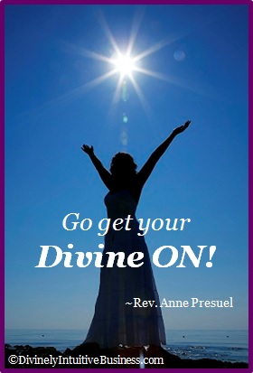
Return now to your body in this space and time. Take a nice deep breath. Feel your feet. If they’re on the floor, feel the ground beneath them. If they’re not, feel your body next to the chair or next to the seat. Just get present to your body. Get a nice deep breath. Return now to this space and time. Open your eyes. Very good. Be here now.

xoxoxo,

Anne

Rev. Anne Presuel
Your 6th Sense Guide to a 6-Figure Business
www.DivinelyIntuitiveBusiness.com

