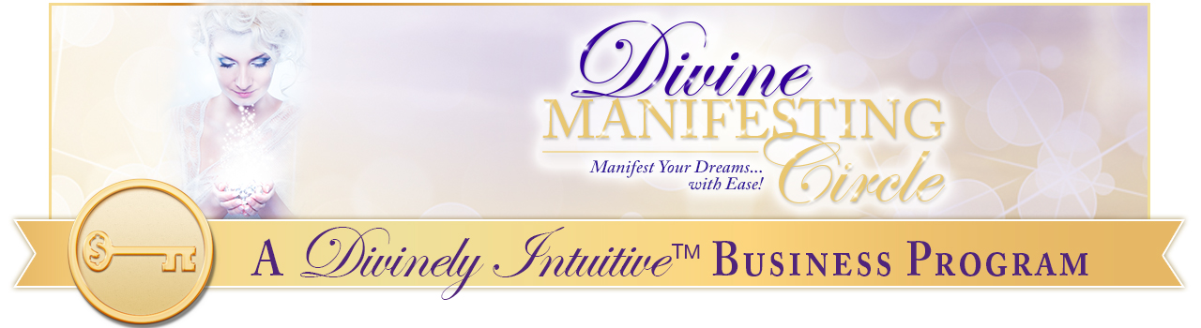

Visualization Script
The Cutting Cords

Get comfortable. Take a nice deep breath. Close your eyes if you like. Probably it’ll work better with your eyes closed. (Pause)

Another nice deep breath in and release.

Allow yourself to see the light surrounding you.

You feel it and know that it’s there.

And maybe see it swirling around you – different colors, pulsing, vibrating. It is a beautiful light.

It is this light of connection that you have with everything around you – your aura.

And allow the light from the Universe, the beautiful pure light from the Universe, to shine down on to you like a ray of the sun, just shining down, mixing with your light, bringing healing, bringing love, bringing joy, and peace.

And breathe it in deeply into your being. Breathe that light into every cell of your being. Let it move deep within.

And with each breath, allow your body to go deeper and deeper. You’re more and more comfortable in the chair, breathing in the light, breathing out anything that is no longer needed.

Now, I want you to see in your mind’s eye, yourself – your beauty, your strength, your magnificence. Be yourself and the light that surrounds you.

And now see one person that you would like to have an emotional freedom from, standing across from you, in your mind’s eye. Just envision them.

Look down at your body and to notice if you have any cords, any energetic cords, connecting you to this person. And if so, notice where they are on your body and where they connect to the other person on their body.

Deep breath in and release. Notice – what does this cord look like? What is the color of the energy on this cord? Is it light? Is it dark? Is it sludgy? And does it go from you to them? From them to you? Does it go both ways? Do you have multiple cords? Just notice.

Very good.

Now we’re going to call in Archangel Michael with his sword of light, for each one here. And ask Archangel Michael to please cut the cords that are connecting you to this other person. Know that everything will be fine, even once they’re cut ––– and that as he cuts them, he seals them.

Notice if there’s anything you need to say to this person or they need to say to you.

Now allow Michael to cut the cord.

Thank this person for what you’ve learned because of them, their presence in your life. And then allow them to simply fade away.

If you have any sadness at all, release it to Archangel Michael. And feel the presence of the other angels coming into you now, holding you, lifting you, healing you, strengthening you.

Know that you can return to this space and time any time you like. You can call in the archangels any time you like. And you can ask Archangel Michael any time you like to cut other cords for you.

As a matter of fact, you could do that on a daily basis, freeing your energy. By doing this you allow yourself to receive more and more through your intuition, for your energy is not being sucked up or bled out by someone else. Rather you are receiving the energy from the Divine.

See yourself, surrounded by the light of the Divine, breathing it in.

Taking a nice deep breath in and releasing it, come back to this moment in time, back to your body, right here, right now. I’m going to count to three, when I get to three, you will open your eyes feeling refreshed, alert, awake, and you will remember everything.

And you will know that you are the child of the Divine, a magnificent being, here to do the work of bringing your gifts to the world and knowing that your people are looking for you to work with. Your friends are looking for you, your loved ones are looking for you, wanting to be with you but not wanting to take from you. Know that you’re protected at all times.

And on the count of three, open your eyes: one, two, three. Open your eyes, take a nice deep breath and stretch.

You might want to journal about what you saw, felt, heard, or thought … whatever you experienced during that visualization so that you can notice how things show up differently for you as you move forward.

xoxoxo,

Anne

Rev. Anne Presuel
Your 6th Sense Guide to a 6-Figure Business
DivinelyIntuitiveBusiness.com

