How to Whitelist Email with Gmail

How to whitelist an email address with Gmail
Sign in to your account at Gmail.com and do the following.

Add the address to your contacts

Add the email address that is sending you email (eg RevAnne@divinelyintuitivebusiness.com) to your Gmail Contacts. Google will usually deliver email from addresses that are in your Contacts.

- In the dropdown menu at the top-left corner of your email, select Contact.
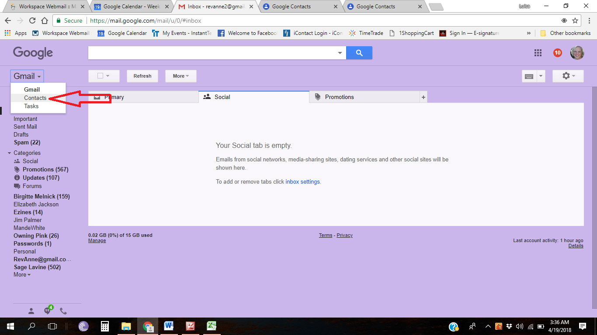

- In the Contact page, click on the icon plus ( + ) at the lower-right corner of the page.

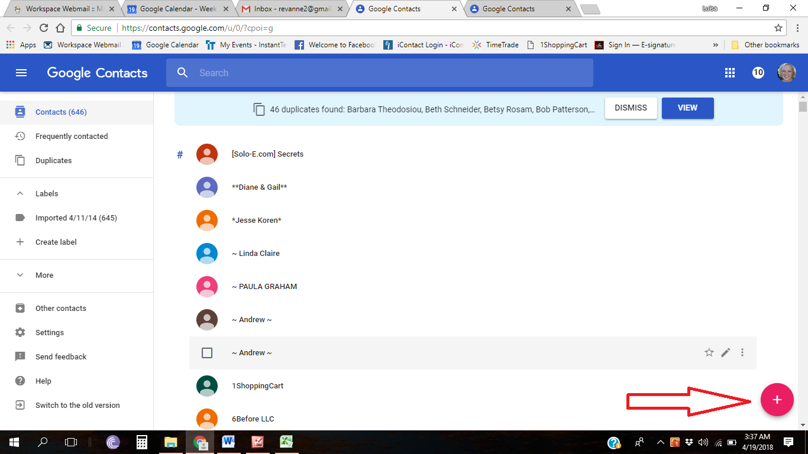

- Add the name & email address in the box (eg Rev. Anne Presuel and RevAnne@DivinelyIntuititveBusiness.com) and hit Save.

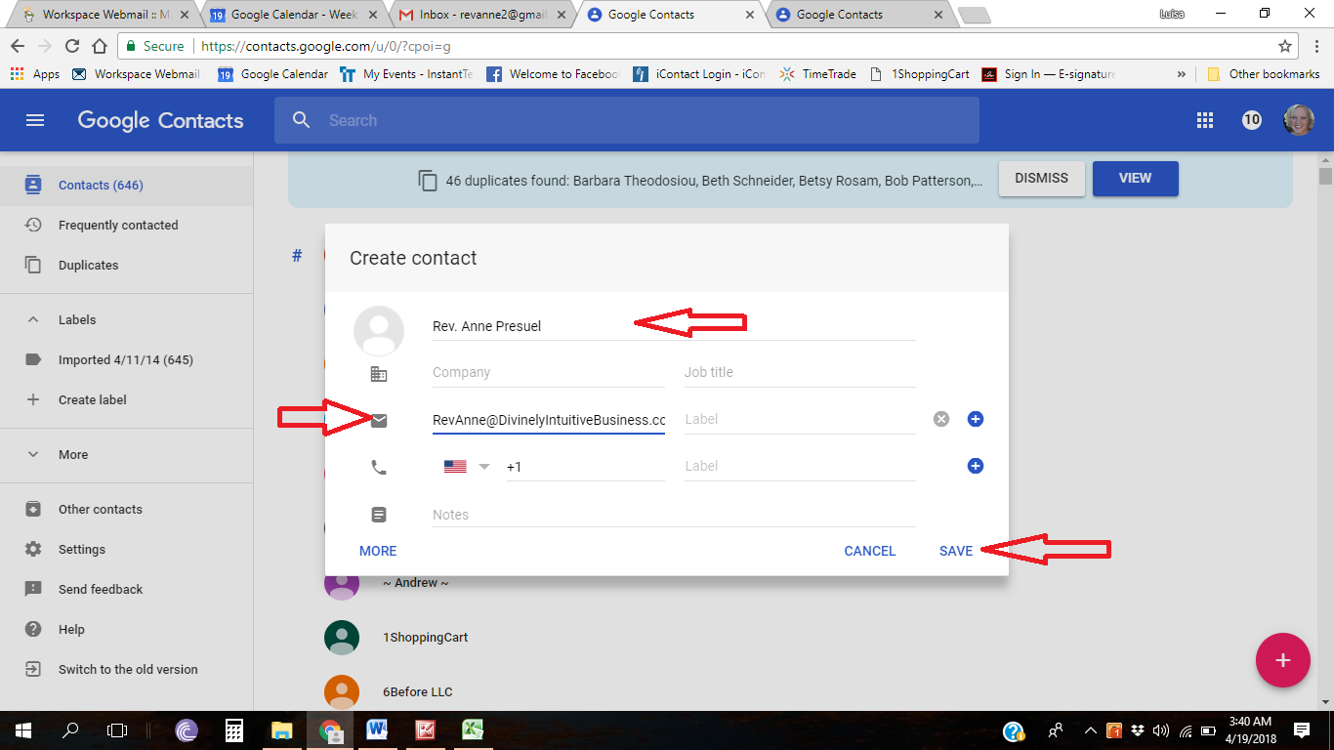

Mark messages as ‘Not spam’

If Gmail has marked emails you wish to whitelist as spam, tell Gmail the emails are not spam.
- In Gmail, navigate to the Spam folder.
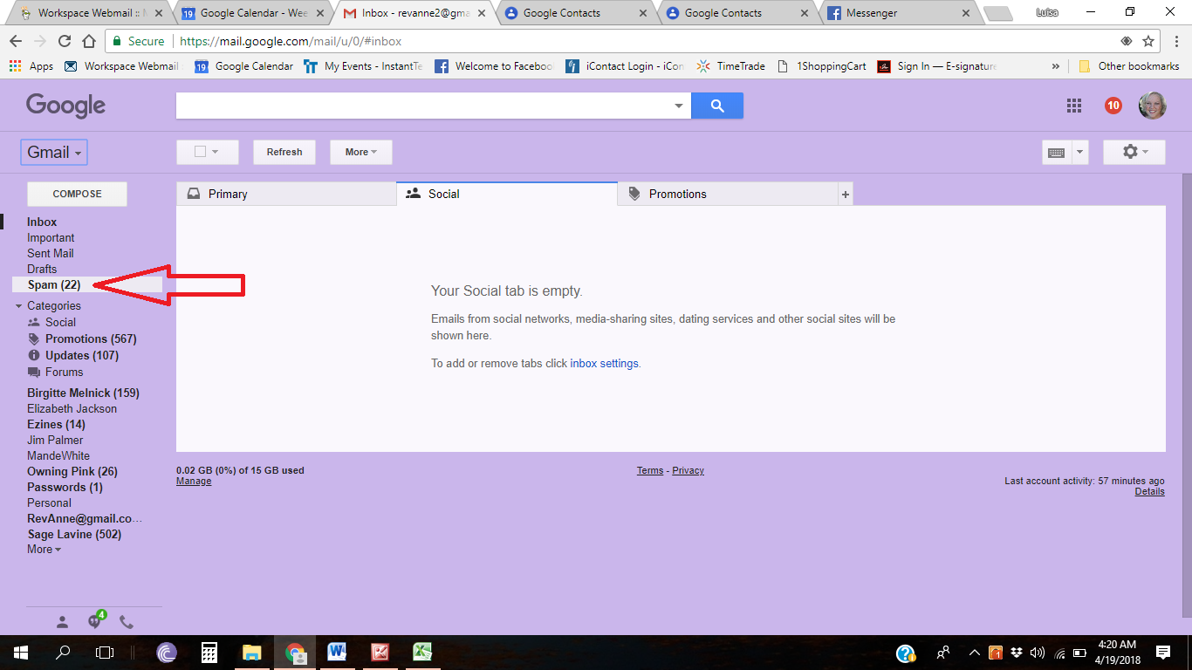

- Search and check on for emails containing the domain you wish to whitelist (eg divinelyintuitivebusiness.com).
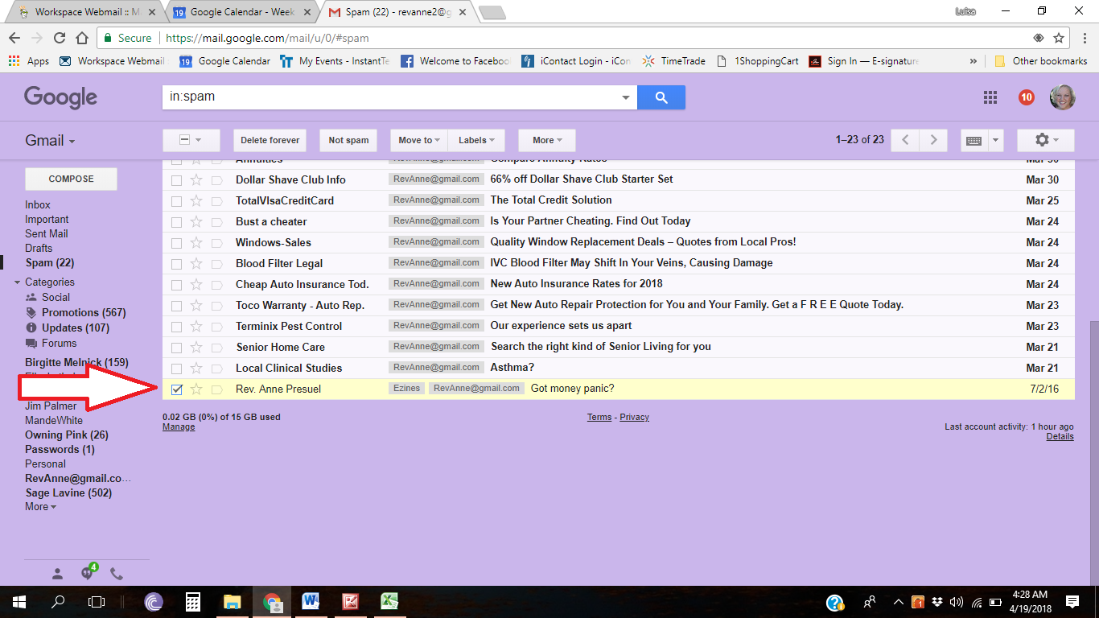

- Click on Not spam.
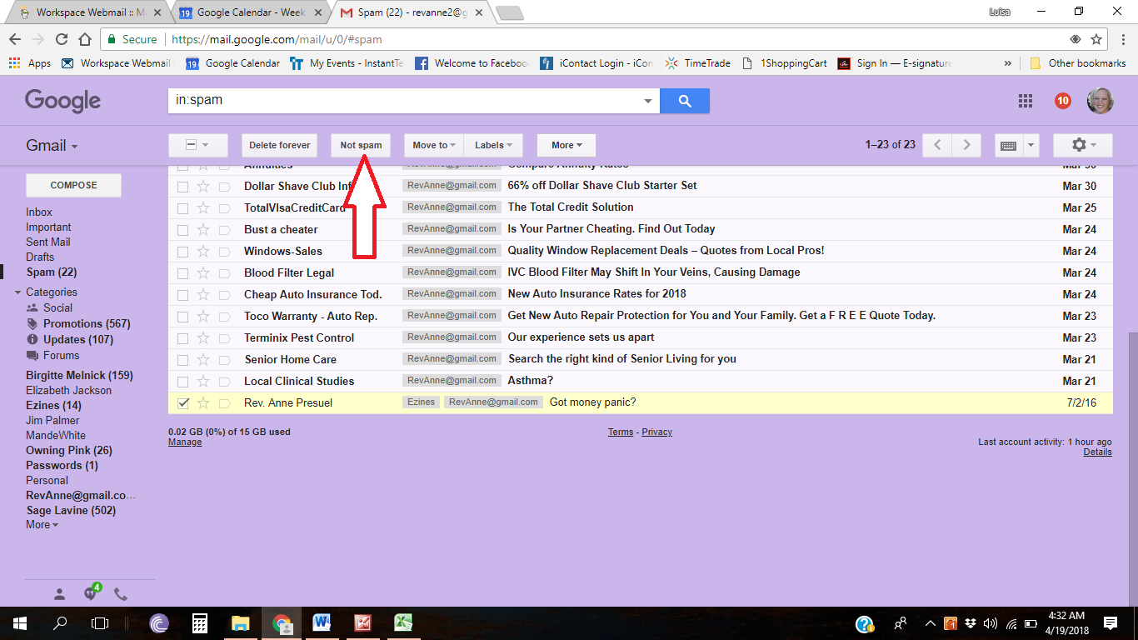

Create a filter for the address

Create a filter to tell Google to whitelist email from a domain or online group.

- Click the cog icon in the top-right corner, and then Settings.
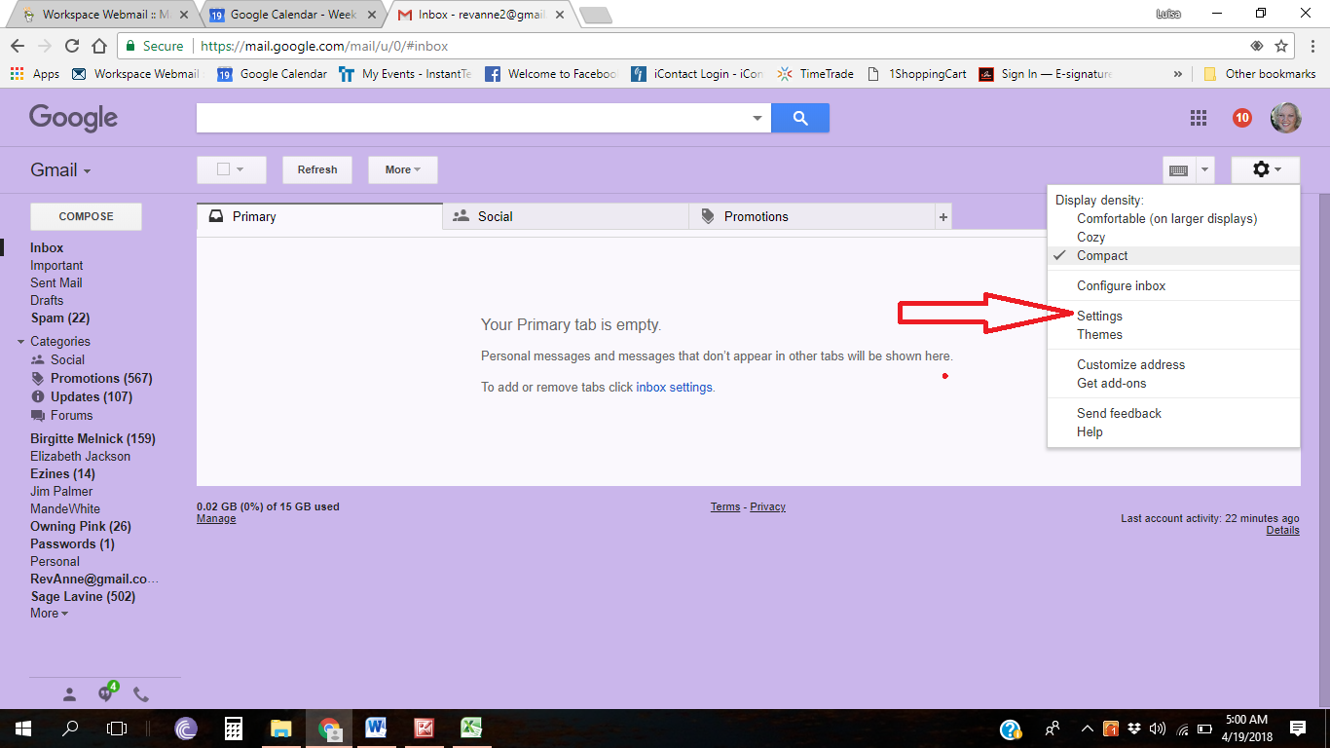

- In the navigation bars, select Filters and Blocked Addresses
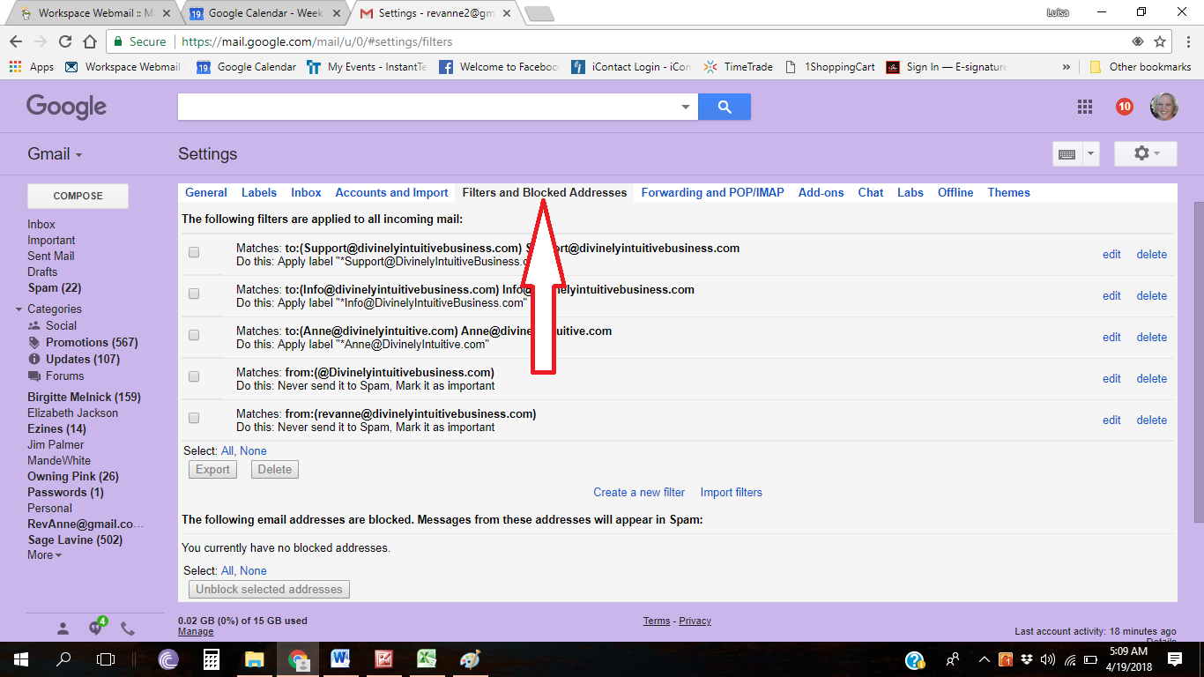

- Click on Create a new filter
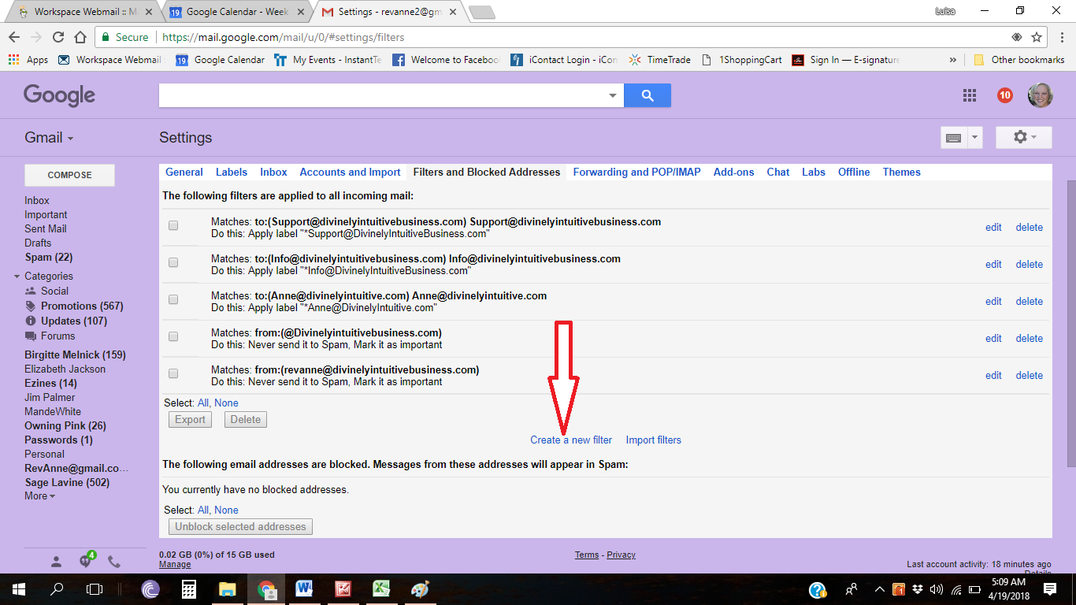

- Either
- enter the domain of the email you want to whitelist in the From field or
- enter the email address of the online group you want to whitelist in the To field

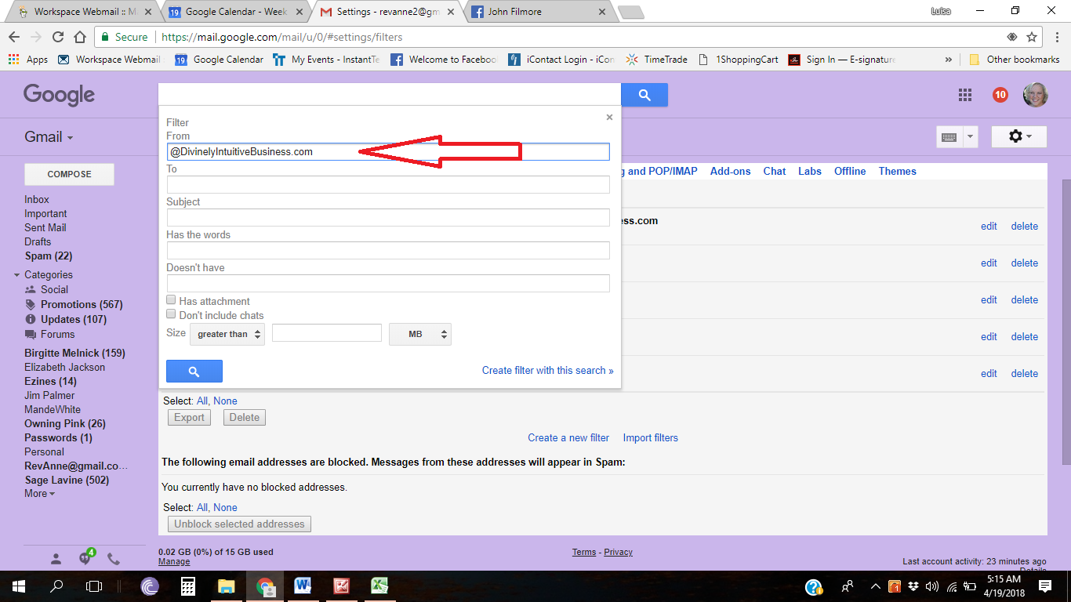

- Click Create filter with this search.
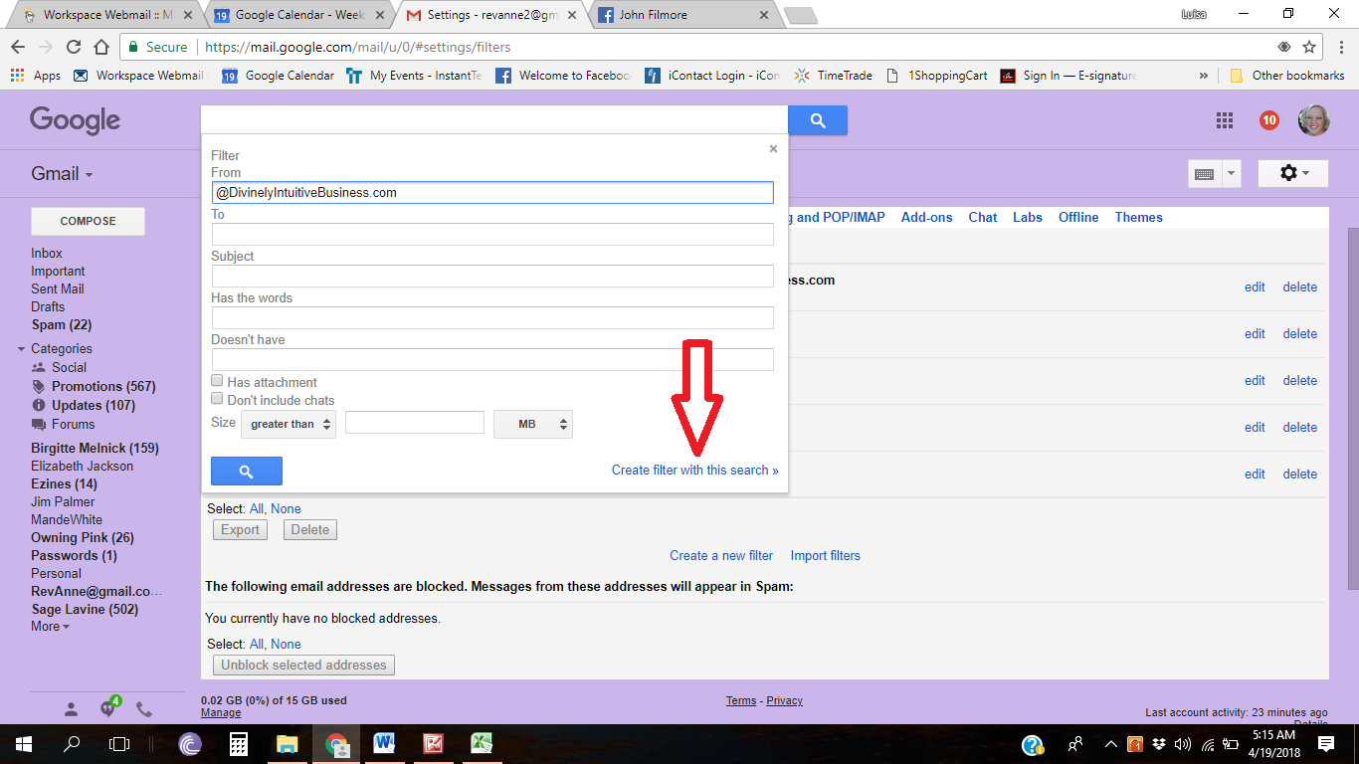

- In the box headed When a message arrives that matches this search select Never send it to spam.
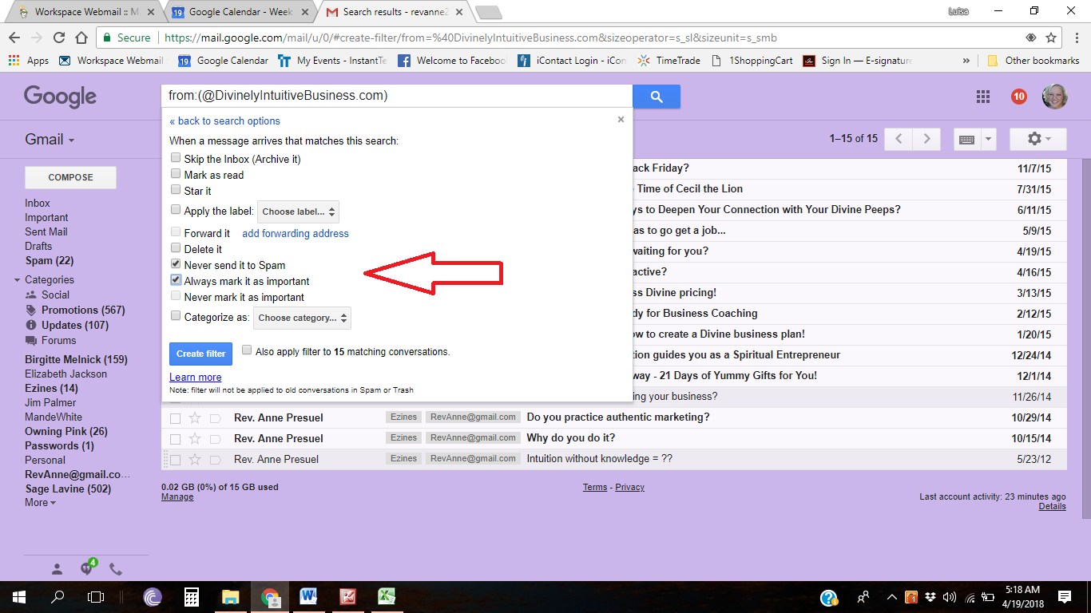

6. Click the Create filter button.

Tips:

- Do not enter email addresses in both the From and To fields as Gmail will only filter in emails that meet both criteria
- In both the From and To fields, you can enter either a specific email address or an entire domain
- To enter multiple domains in each field separate them with OR as in “onlinegroups.net OR groups.yahoo.com”

