Your Divine Celebrations
Module 1 – Handout 1

Let’s begin by celebrating 2018. This helps you own the changes you created, and helps anchor into your energy field the fact that you are a powerful co-creator with the Divine.

- I am very proud of myself that I… (name at least 3)

- What did you do that you feel happy you got accomplished, or understood?

- I said “yes” to this and I’m so glad I did!

- I had to overcome my resistance to this (and I did)! (A software, a belief, a fear, a system)

- When you look back at the beginning of 2018, what did you want to create that you created?

- For whom are you grateful? Team member? Family member? Friend? (Will you tell them that?)

- What was your biggest lesson of 2018?

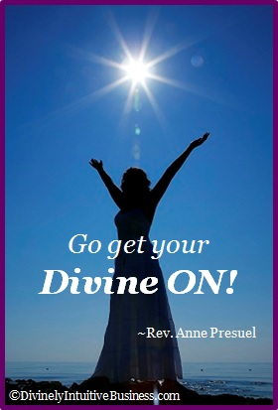

Divine hugs,

Anne

Rev. Anne Presuel
Your 6th Sense Guide to a 6-Figure Business
DivinelyIntuitiveBusiness.com

