Your Divine Challenges
Module 1 - Handout 2

Now let’s move onto the things that you felt challenged about in 2019. These are the energetic attachments that we will be releasing.

- This didn’t work out so well…

- What did you not accomplish that you thought you would (and still have some judgment around)?

- You said “yes” to this and wish you hadn’t…

- You said “no” to this and wish you had…

- What stopped you from taking action in your business in 2019?

- You are still challenged in this area (and intend to work on it in 2020)…

- When you look back at the beginning of 2019, what did you want to create that you still have not created?

- Was there someone or something you brought into your business or your life that you released or want or need to release?

- What belief(s) are you ready to release because it no longer serves you?

- What was the soul lesson that you learned this year that you could learn no other way?

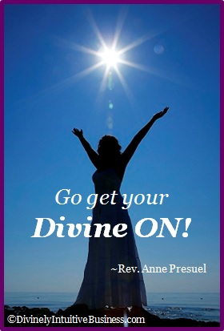

Divine hugs,

Anne

Rev. Anne Presuel
Your 6th Sense Guide to a 6-Figure Business
DivinelyIntuitiveBusiness.com

