Your Divine Gifts
Module 1 - Handout 3

In the visualization we did, you were asked to look at your challenges from last year and to get the Divine guidance as to what your gifts were from having gone through those challenges.

As conscious beings, we know that even when we experience something we don’t want consciously, we can later look back and see how powerful the learning experience was from having made the choices we made. We know that we couldn’t have gotten the learning any other way.

In this handout, you are to write down the guidance you received so that you can let go of any “shoulds” or shame or any make-wrong you may be doing to yourself, and so that you can understand more fully the perfection of your process.

Please fill out the prompts below:

- What happened and how you felt about what happened.

- What did your Divine guidance tell you about the learning gift(s) you received form this choice/experience?

- What was the gift from having taken that action?

- What was the blessing?

- What was the soul lesson you learned you couldn’t learn any other way?

- I choose to accept this guidance. (yes/no)

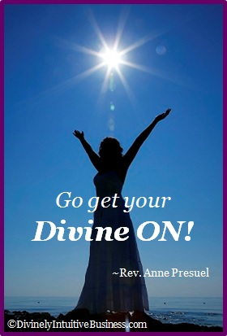
Divine hugs,

Anne

Rev. Anne Presuel
Your 6th Sense Guide to a 6-Figure Business
DivinelyIntuitiveBusiness.com

