Your Divine Yes!
Module 3 Handout 1

What was the biggest ah-ha from connecting with your business and your future self?

- What guidance will you take forward?

- What do you need to release in order to create your vision?

- Are you willing to release it?

- What support do you need to take the guidance you received?

- Will you give it to yourself? By when?
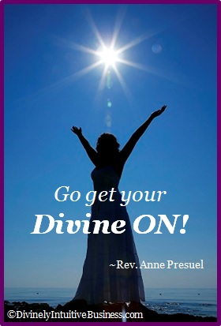

Divine Hugs,

Anne

Rev. Anne Presuel
Your 6th Sense Guide to a 6-Figure Business
DivinelyIntuitiveBusiness.com

