Your Divine Celebrations
Module 1 – Handout 1

Let’s begin by celebrating 2020. This helps you own the changes you created, and helps anchor into your energy field the fact that you are a powerful co-creator with the Divine.

- You are very proud of yourself that you… (name at least 3)

- What did you do that you feel happy you got accomplished, learned, or understood?

- What did you say “yes” to this and you’re so glad you did!

- You overcame your resistance to this.

- When you look back at the beginning of 2020, what were your intentions?

- What did you create that you wanted to create?

- For whom or what are you grateful? (Will you tell them thank you?)

- What was your biggest lesson of 2020?

- How would you describe 2020?

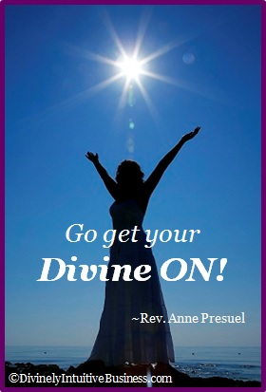
Divine hugs,

Anne

Rev. Anne Presuel
Your 6th Sense Guide to a 6-Figure Business
DivinelyIntuitiveBusiness.com

