Create Your Divine Vision
Module 2 – Handout 1

Write below the information about the vision you received as you went through the meditation, Create Your Divine Vision.

- Were you able to connect with your future self?

- What did your future self tell you about your upcoming year?

- What words of wisdom, compassion and love did your future self share with you?

- Did you see yourself 12 months from now? What was happening?

- Did you have any resistance to what you were shown? If so, what?

- Did your future self tell you to let go of anything in order to create what you want?

- Are you willing to do that?

- What advice did your future self share with you to make your journey easier?

- What word(s) for 2021 came to you during the meditation?

Thank you, God.
I know that this or something better is showing up in my life.
And so it is.

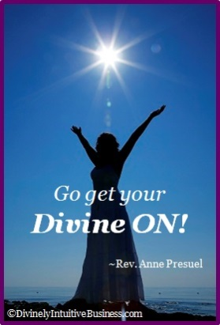

Divine hugs,

Anne

Rev. Anne Presuel
Your 6th Sense Guide to a 6-Figure Business
DivinelyIntuitiveBusiness.com

